Be a Hunger Hero

Tools for your Food Drive, Fund Drive, or Special Event
The work of the Blue Ridge Area Food Bank is often described in numbers that are difficult to comprehend – millions of meals, thousands of families, hundreds of community partners. We are frequently asked, “How can I make a difference? I’m just one person.”
But making a difference all begins with one – one person in need, one neighbor who cares, one hand to lift up another. It starts with you.
Thank you for being a Hunger Hero.

Table of Contents
Food Drive, Fund Drive, or Special Event 2
Food Drive 3
Food Drive A, B, Cs 3
Our Healthy Food Wish list 4
Virtual Food Drives 5
Fund Drive 6
Fund Drive 1, 2, 3s. 6
Special Event 7
What Makes an Event Special. 7
Promoting your Effort 8
Understanding Hunger: Quick Facts 8
Press Release Template 9
Food Drive Poster for Collection Box (editable) 10

Most-Needed Foods Poster for Events (can be printed up
to size 24x36.) If your printer can’t print pages larger than
letter size, you can scale this page to fit the paper: Choose
File > Print. Click Size, and choose Fit…………………………11

Most-Needed Foods Shopping List (designed to print and
cut to hand out as grocery shopping list)……………………..12
Blue Ridge Area Food Bank Branch Locations 13

Lend a Hand

All that we accomplish at the Blue Ridge Area Food Bank (BRAFB) starts with a hand – a hand that drops a can of food into a donation barrel; a hand that writes a check to fund our work; hands that sort and package food in boxes and bags before it is passed along to a person in need.

Whether your gift of time and energy is through participation in a special event, food drive, or fund drive, we want to provide support and guidance to make your experience a success. The following pages include helpful tips, promotional materials, and guidelines to walk you through those steps.
First, determine what type of campaign you are planning. The following definitions will guide you to the section of this toolkit you will find most helpful:
A food drive (page 3) has a singular focus: collecting non-perishable food items for the Food Bank. These are typically multi-day or weeks-long undertakings.
A fund drive (page 6) has a singular focus: collecting financial donations for BRAFB. These can be of any length of time and are often in coordination with a food drive or special event.
A special event (page 7) is a single occurrence in a finite period of time, typically a one-day or evening time frame. These may have both a fund and a food drive component but, they are characterized by their time frame and intent.

QUESTIONS?
Send an email to solvehunger@brafb.org and we’ll connect you to someone who can help.

Good luck, and thank you!

Food Drive A, B, Cs

Your donations are more vital than ever, and hosting a food drive is a fun and simple way to help. Here are a few tips to make your drive a success.

READY…
Establish a team or a committee to organize the food drive. Create a theme, set goals, plan logistics and develop a timeline.
See our wish list (page 4) to develop your food drive theme. For example:
Meat the Need: canned meats and canned beans
Back to School: granola bars, fruit cups, bite- size crackers
Supper Sides: boxed pastas, rice, soups and macaroni and cheese
Five a Day: canned fruits and vegetables
Peanut Butter: one of the items in highest demand and most versatile. Include Almond Butter and you’ll help people with peanut allergies.
SET…
- Obtain sturdy collection boxes or bins.
- Establish food drop-off locations.
- If you’d like one of our barrels for your food drive, please consider the following questions before placing your request:
- Do you expect to collect at least 250 pounds of food (approximately what a barrel will hold)?
- If you’re hosting an annual activity, consider historical food collection totals. Did your collection exceed 250 pounds last year? (We can find out for you, if you don’t know)
- Will your food drive last two weeks or longer?
- Will your food be collected in a location that is visible to “foot traffic,” thereby helping to raise visibility for the Food Bank?
- If the answer to all of these questions is yes, you could benefit from using one of our barrels. Contact us at fooddrive@brafb.org to reserve your barrel.
- If the answer is no, we suggest that you prepare a cardboard box or other collection receptacle of your own and utilize our customizable food drive poster (page 10) to market your efforts.
- Contact the Food Bank before the drive ends to discuss delivery of the food (page 4).
- Promote the food drive through a company newsletter, emails to staff, flyers, posters (page 10), or leaflets (page 12) and on social media (page 8). Be sure to share the Food Bank website – www.brafb.org.
- You can offer incentives such as a prize drawing entry for those who give. To encourage participation, send a bag home for employees to fill with food.
- Organize a group to tour the Food Bank and/or volunteer prior to or after the food drive. It makes a big impression to see our work in action!

GO!
Wish List
All food donations should be non-perishable. NO GLASS PLEASE.
Most desirable items include proteins such as canned tuna, salmon or chicken, peanut butter, almond butter, beans, and canned nuts.
Low sodium, low sugar, and whole grain items are preferred.
Dairy items such as canned, evaporated, or powdered milk are in high demand.
Fruits and vegetables including 100% juice in boxes and cans, low- or no- sodium canned vegetables, and fruits in light syrup or fruit juice.
Boxed pasta, rice, cereal, canned soups and stews, and macaroni and cheese are some other items that are always appreciated.
Our Healthy Food
Happy shopping and collecting! Let us know if we can help throughout the drive. When shopping, please keep Our Healthy Food Wish List in mind.

WHEW…
- Once your food drive has concluded, please contact us to discuss drop-off or delivery options. It’s important that we dedicate the Food Bank’s resources to purchasing more food instead of expensive fuel, so we ask that you commit to collecting a minimum of 250 pounds (approximately one full barrel) if you are requesting a delivery or pickup. If you are hosting a smaller drive, simply schedule a time to visit the Food Bank branch near you to deliver your food (see page 13 for locations).
- We will send you a receipt for the total pounds collected.
- Share/publicize your results among staff and in local media (see sample press release on page 9).
- Celebrate! Review the event and set the date for next year. Thank you for your support!
How else can you help? If you don’t want to shop for a food donation, let us buy it for you. We take financial donations; in fact, just $1 provides 4 meals! Give online at www.brafb.org. Or set up a virtual food drive on our
website.

QUESTIONS?
Send an email to solvehunger@brafb.org and we’ll connect you to someone who can help.

Virtual Food Drives

Your donations are more vital than ever, and holding a virtual food drive is a fun and simple way to help. Here are a few tips to make your drive a success:

READY…
If you haven’t already, pick the dates for your drive and complete the Virtual Food Drive application here to let us know your plan – we can help with promotion and answer any questions. Next:
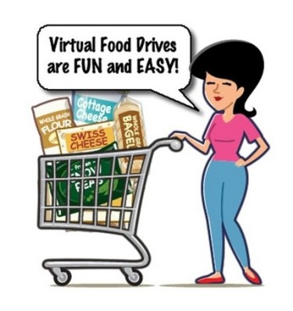
- Find out if your company has a matching program. If so, engage them! It’s a great way to increase your drive totals.
- Personalize your drive with a logo or team name.
You will receive an email with your username, password and login code to access your customized Virtual Food Drive.

SET…
- Promote your food drive through email, social media, company newsletter, flyers, and just plain old word-of-mouth using the URL we have provided.
- Send a welcome message to everyone participating and then send them a reminder as the close of your drive approaches.

- Be sure to share the Food Bank website – www.brafb.org where your collaborators can learn about hunger and the impact of their support.
- Remind everyone for every $1 donated, BRAFB can provide enough food for 4 meals! Their financial donations can stretch much further through us.
- You will be able to access your drive at any time to check on the status of your goal – share the news Everyone wants to know they are making a difference.
- If you’re hosting an annual activity, consider historical collection totals – make it a goal to “beat last year’s goal” or “let’s double our meals from last year!”
- Organize a group to tour the Food Bank and/or volunteer prior to or after the food drive. It makes a big impression to see our work in action!

GO!
Happy shopping and collecting! Let us know if we can help throughout the drive.

Each person participating in your drive will receive an emailed receipt for their donation.

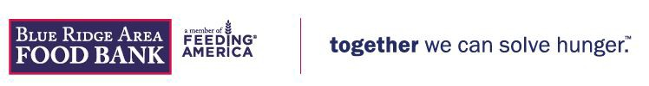

WHEW…
Once your Virtual Food Drive has concluded, we will send you a letter reporting the total amount collected through your efforts. Please share your results among friends, family and/or staff – one of the most important accomplishments of your drive has been the increased awareness of hunger and ability we have to make a difference in our own community.

Now celebrate! Review the event and set the date for next year. Thank you for your support!

QUESTIONS?
The email containing your username, password and login will include the name and information for your BRAFB contact. Please feel free to reach out with questions.

Fund Drive 1, 2, 3s

For every $1 donated, we are able to provide 4 meals! So whether your fund drive is in your neighborhood, your school, your business, or across the state, here are some helpful hints to make it a success:
FIRST: Plan
Establish your target audience and set a goal for your drive. If your goals are lofty, recruit a team or committee to help organize the drive, plan logistics, develop a timeline, and decide how you will promote and encourage participation.
(Make sure donation/collection sites are well documented, secure, easily accessible, and convenient for your participants.)
Create a theme or make it a competition – you want it to be fun for you and everyone involved! Theme ideas:
“Off My Plate” Day – while about 1 billion people globally do not have enough to eat, Americans toss out about 40 percent of all U.S.- produced food. Challenge your participants to record the amount of food they throw out in just one week and make a contribution to the food drive in that amount.
Brown Bag for Hunger – ask everyone to bring in their lunch or have a potluck and ask each participant to contribute what they would normally spend on lunch out to your efforts.
Friendly Competition – spread the word to neighboring businesses and groups to gain their participation and track who can raise the most for your drive. Celebrate the winner.
Prize – throw a party for all who participate and award the top donor or the individual who recruited the most donors.
SECOND: Promote
Spread the word! Use our poster (page 11), email, word of mouth, and social media. Remember to “Like” our Facebook page and follow us on Twitter. Be sure to mention us by name in any posts or tweets so we can help spread the message. See page 8 to connect with us on social media.
Contact local newspapers, and radio and TV stations using our press release template (page 9). Add your event to online community calendars at media websites.
Track your results and provide updates. Everyone wants to know how they are making a difference.

THIRD: Give
Collect all donations and deliver to your local Food Bank branch (page 13) OR, if you would prefer to have a check presentation ceremony, contact solvehunger@brafb.org to explore the possibilities.
If individual donors request a receipt and/or tax credit, we must receive their contribution as a check made payable to: Blue Ridge Area Food Bank. Also, be sure to include the name of your drive or campaign on the memo line so that we can attribute the gifts appropriately.

CELEBRATE
Share/publicize your results among participants and in local media (see sample press release on page 9) and on social media (tag the Food Bank so that we can celebrate with you). Review the event and set the date for next year! Thank you for supporting Blue Ridge Area Food Bank!

QUESTIONS?
Send an email to solvehunger@brafb.org and we’ll connect you to someone who can help.

What Makes an Event Special?

A special event is a wonderful way to support the work of the Food Bank. Not only does an event generate much-needed funding, but it can bring awareness to a new, larger audience.
Thank you for helping to share our story and raise awareness of our programs and the necessary funding to support them. Let us know when your plans are in place so we can add your event to our calendar.

PLANNING A SUCCESSFUL FUNDRAISER
- Choose a planning team – Involve enough volunteers to share the work load.
- Set a goal and develop a budget – Work with the end result in mind. Identify all possible sources of revenue and anticipated expenses.
- Choose the right event – Be sure that your event complements Blue Ridge Area Food Bank’s mission to end hunger in central and western Virginia. Is the event unique to your community?
- Who’s your audience? – Plan a date and time that is appropriate and convenient for those you want to attend.
- Promote /publicize your event – Use all appropriate tools to spread the word about your event. Consider sending a press release (page 9) to local media. Make good use of social media! Share/publicize your event with others! Use posters
(page 11), email, word of mouth, and social media. Remember to “Like” our Facebook page and follow us on Twitter. Tag us when you post about your event so that our fans and followers can see all the good things you’re up to! See page 8 to connect with us on social media.
- Make your donation – Please turn in all proceeds to the Food Bank within 30 days of your event. All checks should be made payable to: Blue Ridge Area Food Bank. If individual donors request a receipt and/or tax credit, we must receive their contribution as a check made payable to: Blue Ridge Area Food Bank. Also, be sure to include the name of your drive or campaign on the memo line so that we can attribute the gifts appropriately.
- Say THANK YOU! – Acknowledge everyone who participated in or supported your event.

SETTING IT IN MOTION
Consider the following questions:
Date and Time – Does the event conflict with any other significant events planned for that time? Is this an after-hours event?
Potential Audience – What is the target number of attendees to make it successful? Will the event be held if your target number is not reached?
Potential Revenue – Is the potential revenue in balance with the expected expenses? Is any portion of the revenue going elsewhere? How will the money/donations be collected?
Staff Requirements – Our resources are limited, but we’d like to help you if we can! Examples of BRAFB assistance: food collection (barrels), fund collection, promotion, attendance.
Stewardship – How will the participants be thanked for their participation?

QUESTIONS?
Send an email to solvehunger@brafb.org and we’ll connect you to someone who can help.

Promoting Your Effort

Here are a few helpful hints to promote your Hunger Hero effort:
UNDERSTANDING HUNGER
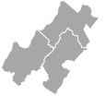
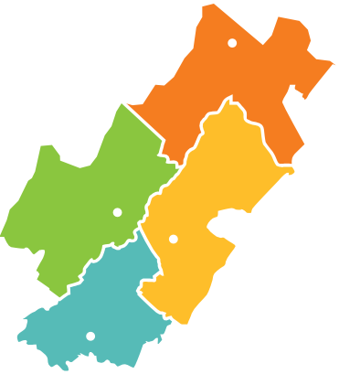
Hunger is still a big problem, even when the economy feels better to many of us. Many of the people waiting in line for food assistance are employed and working hard to make ends meet, but their jobs aren’t adequate to support them and their families. Those who depend on the Blue Ridge Area Food Bank are often the most vulnerable – seniors struggling to meet basic needs on a fixed income, and children who need to be well-nourished during their formative years in order to thrive.

WINCHESTER
Use the following hunger facts to cheer on and encourage your team, and to educate your community about the need:
- The Blue Ridge Area Food Bank (BRAFB) serves an average of 105,100 people each month.
- The Lynchburg area branch (Lynchburg) serves approximately 16,585 people each month.
- The Lord Fairfax area branch (Winchester) serves approximately 34,537 people each month.
- The Thomas Jefferson area branch (Charlottesville) serves approximately 22,826 people each month.
- The Shenandoah Valley branch (Verona) serves approximately 31,556 people each month.
- BRAFB provides over 21 million meals each year, or more than 25 million pounds of food.
- 1 of every 7 children in the BRAFB service area live with food insecurity, unsure of where their next meal will come from.

VERONA

LYNCHBURG

CHARLOTTESVILLE

The Blue Ridge Area Food Bank serves 25 counties and eight cities in central and western Virginia.
- Seniors are the fastest growing group of people depending with increasing frequency on charitable food assistance.
- For every $1 you give, we can provide 4 meals to our neighbors in need.
For more Hunger Quick Facts visit www.brafb.org.

Follow Us

Facebook www.facebook.com/blueridgeareafoodbank
Twitter www.twitter.com/brafb
Instagram www.instagram.com/brafb
YouTube www.youtube.com/user/BRAFB1

Remember to “Like” our Facebook page and follow us on Twitter and Instagram. Tag us when you post about your event so that our fans and followers can see all the good things you’re up to!

Press Release Template

FOR IMMEDIATE RELEASE [YOUR ORGANIZATION’S LOGO]

Contact: [NAME]
[PHONE] [E-MAIL]
[WEB ADDRESS]
[HEADLINE]
[SUBHEAD]

[(CITY, STATE - DATE)] –

- Begin with a paragraph stating exactly what is happening, including time, date and location (in that order).
- Second paragraph should detail the attractions of the event.
- Third paragraph should explain why it’s important for the community to become involved.
- Final paragraph should include additional ways to get more information: (Web site/e-mail/phone, etc…)
- A good press release does not exceed one page. It is straightforward, easy to read and relatively brief.

[YOUR ORGANIZATION’S BOILERPLATE – OPTIONAL] (See below for Food Bank’s
boilerplate as an example.)

About the Blue Ridge Area Food Bank
Founded in 1981, the Blue Ridge Area Food Bank is the largest organization alleviating hunger in western and central Virginia. Headquartered in Verona, VA, the Food Bank serves 25 counties and eight cities through distribution centers in Charlottesville, Lynchburg, Winchester and Verona. The Blue Ridge Area Food Bank distributes over 25 million pounds of food annually to 105,100 people each month through a network of 212 community partners – food pantries, soup kitchens, shelters, schools, churches and other non-profit groups. The Food Bank is a member of Feeding America, a national food bank association that supports 200 food banks across the United States. For more information, visit www.brafb.org.

# # #

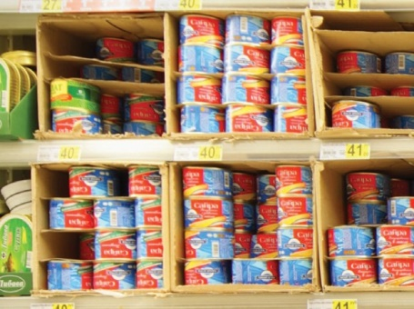
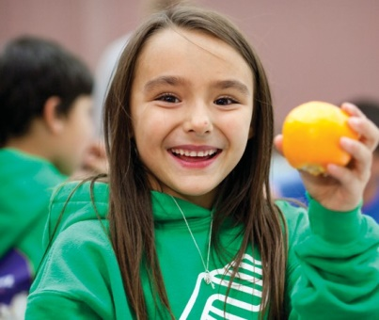
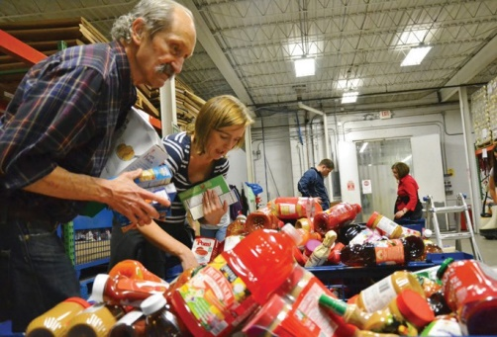
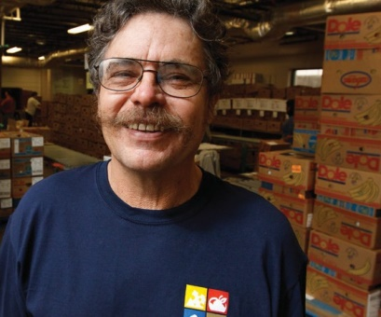
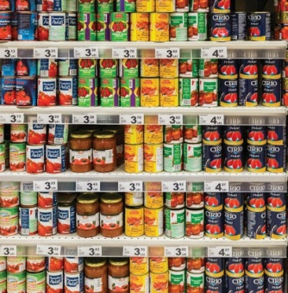
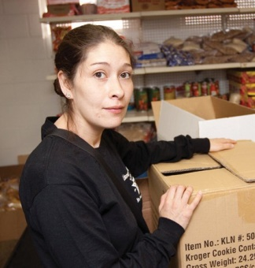
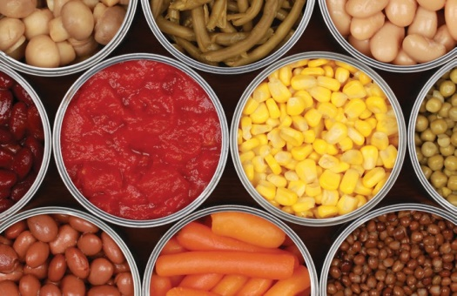

FOOD DRIVE

[Event Title]

[Event Time and Date]

www.brafb.org
Drop non-perishable food donations here to help neighbors in need!

SPONSORED BY: [YOUR ORGANIZATION]

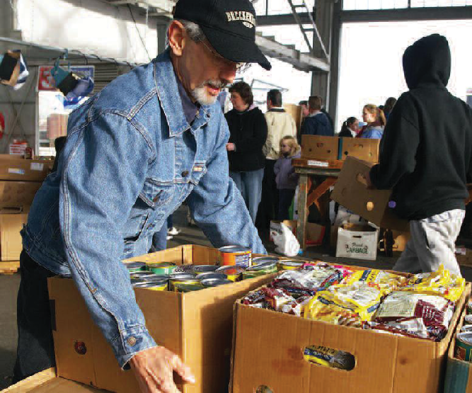
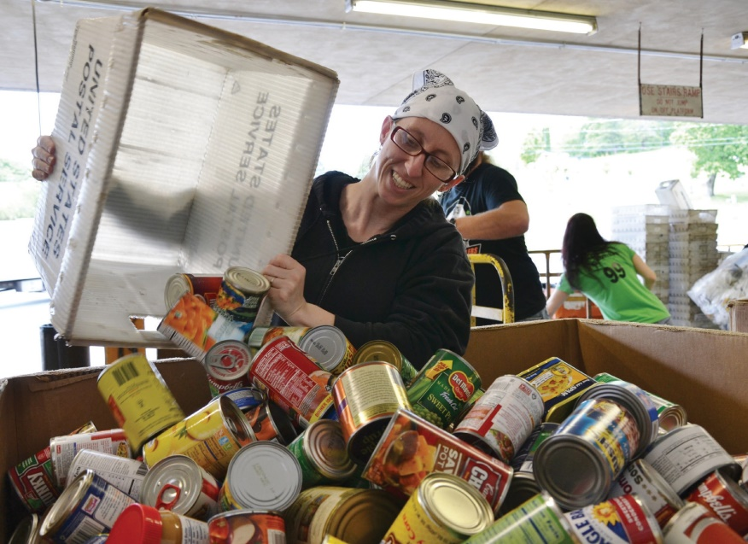
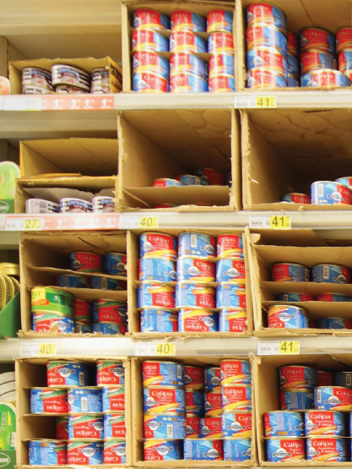
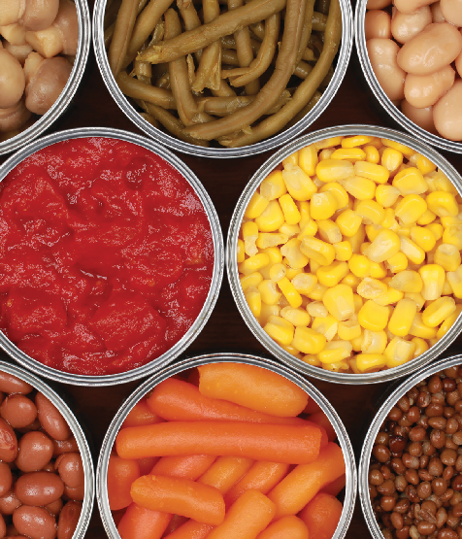
BE A HUNGER

[Call To Action]

[Event Title]

[Event Time and Date]

together we can solve hunger.

SPONSORED BY: [YOUR ORGANIZATION]

www.brafb.org
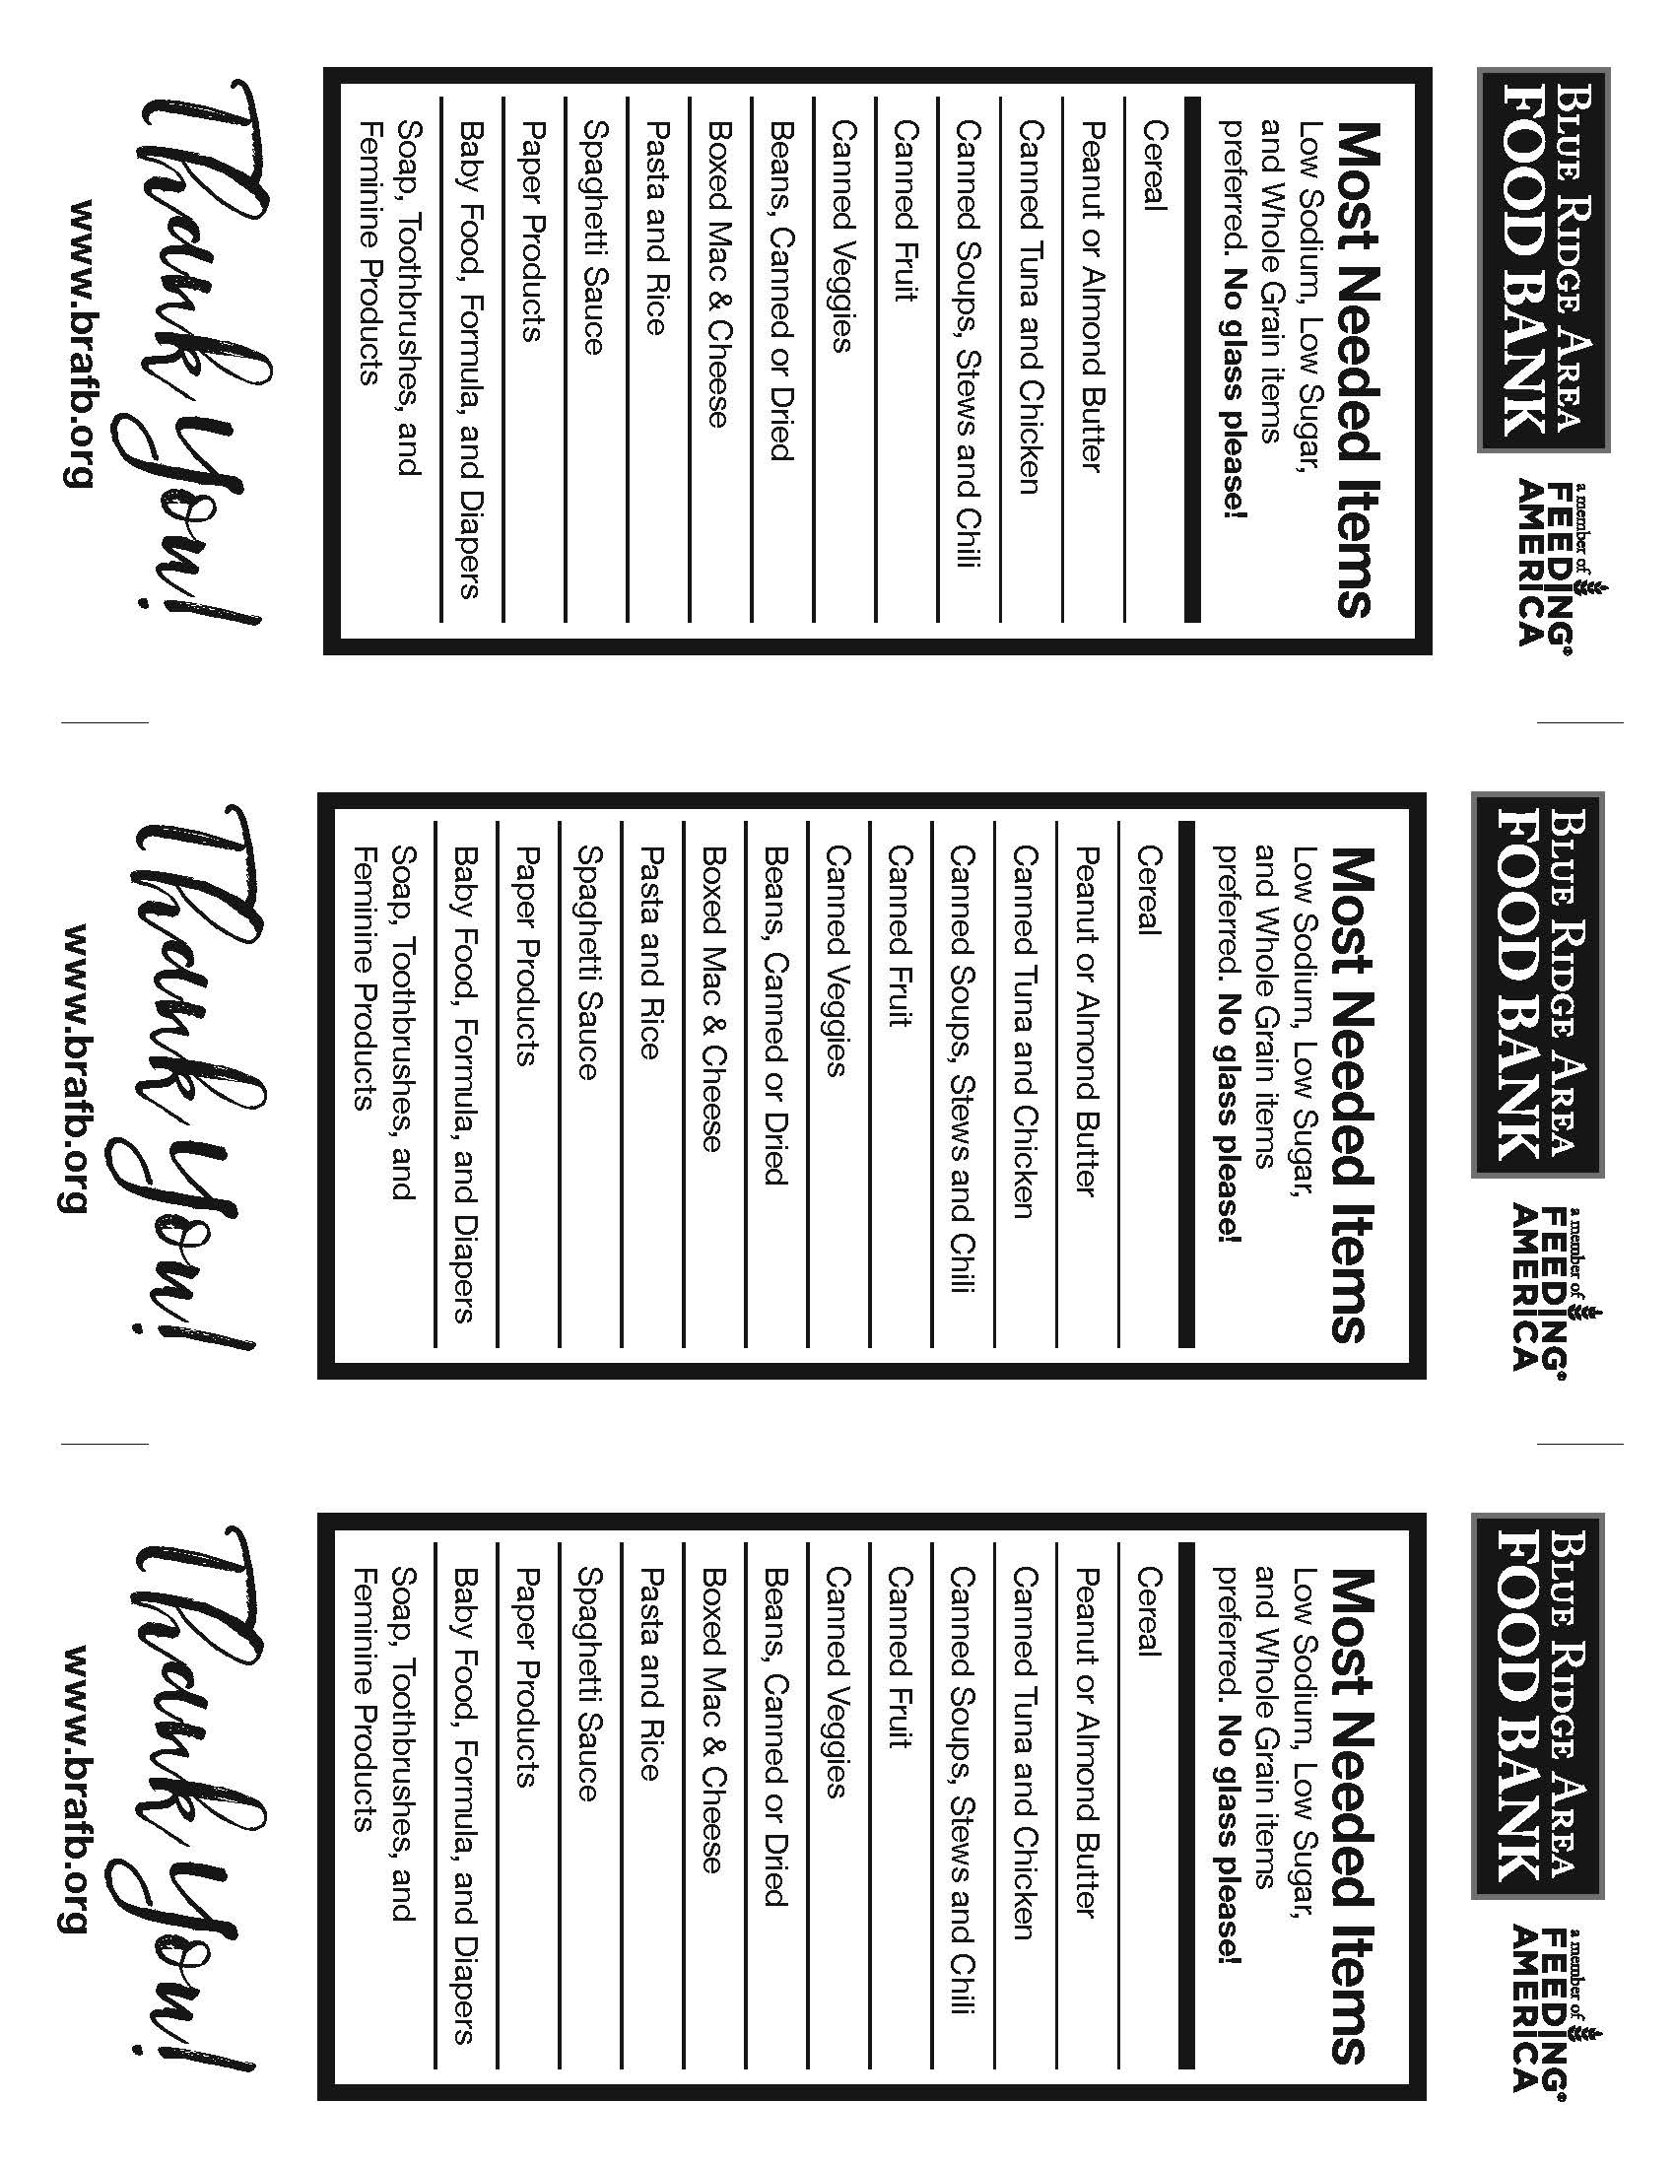
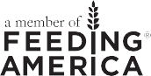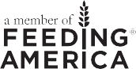

Blue Ridge Area Food Bank Branch Locations

Thank you for being a Hunger Hero. Your generous support and participation in the fight against hunger enables us to feed our hungry neighbors, daily.

Web: www.brafb.org
Email: solvehunger@brafb.org

Shenandoah Valley Area Branch & Headquarters Office
PO Box 937
96 Laurel Hill Road Verona, VA 24482-0937
Hours of operation: Monday-Friday, 8:30am to 5:00pm

Thomas Jefferson Area Branch
1207 Harris Street
Charlottesville, VA 22906-6415
Hours of operation: Monday-Friday, 8:00am to 4:30pm

Lynchburg Area Branch 501 12th Street, Suite B Lynchburg, VA 24504-2527
Hours of operation: Monday-Friday, 8:00am to 4:30pm

Lord Fairfax Area Branch
1802 Roberts Street
Winchester, VA 22604-2342
Hours of operation: Monday-Friday, 8:00am to 4:30pm

www.brafb.org 13

