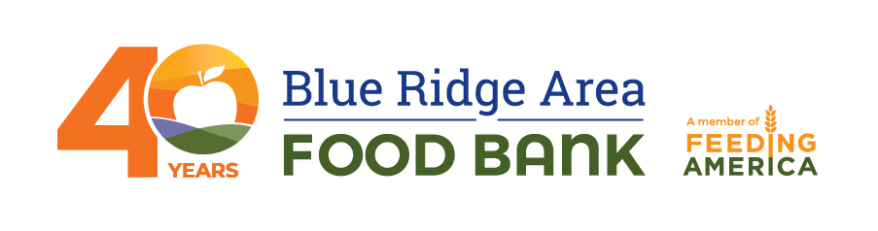
Contact:
Evans Mandes
emandes@hodgespart.com
703-677-2087

637,892 MEALS SECURED: BLUE RIDGE AREA FOOD BANK ANNOUNCES RESULTS OF UNITY IN COMMUNITY FOOD & FUND DRIVE

VERONA, Va. (Aug. 18, 2021) – The Blue Ridge Area Food Bank recently concluded its inaugural Unity in Community Food & Fund Drive where the organization collected enough food and funds from across the entire 25-county service area to provide 637,892 meals for families in need of food assistance. The generosity of the community enabled the Food Bank to surpass its goal of 400,000 meals to honor the Food Bank’s 40th anniversary.
“The generosity of our community never ceases to amaze our team,” says Michael McKee, CEO of the Blue Ridge Area Food Bank. “To all who participated in the Unity in Community Food & Fund Drive, thank you. Your support will have a direct and immediate impact on those in need throughout the region.”
Critical to the success of the event was a generous matching gift from Virginia Estates, Hazy Mountain Vineyards, and Friends. In fact, during the event, the partners boosted their original matching gift as they received progress updates on the fund drive. Witnessing the community’s generous response, one partner and long-time donor to the Food Bank shared, “The more we give, the more we feel compelled to give.”
One out of 12 adults and children in the Blue Ridge area is food insecure. Currently, an average of nearly 119,000 individuals visit the Food Bank and its partner food pantries each month. The Blue Ridge Area Food Bank projects greater need in the fall, given historic trends in food assistance, rising inflation, and the expiration of pandemic-driven government benefits and protections.
The Unity in Community Food & Fund Drive was held from August 7 through August 14. In addition to monetary donations made via its website, the Food Bank collected food donations at seven drop-off locations throughout the Blue Ridge region.
For more information, individuals can visit www.brafb.org/event/unity-in-community.
For additional resources, visit the Food Bank’s newsroom webpage.
###
About the Blue Ridge Area Food Bank
Founded in 1981 and headquartered in Verona, Virginia, the Blue Ridge Area Food Bank is proud to mark 40 years of providing nourishing food to our neighbors in need. As the largest organization alleviating hunger in western and central Virginia, the Food Bank serves an average of nearly 119,000 individuals each month across 25 counties and eight cities through distribution centers in Charlottesville, Lynchburg, Winchester, and Verona. This 40th year is like no other: Together with our network of 203 community partners and 180 program sites, we’re serving record numbers of Virginians during a prolonged pandemic and its associated economic impacts. We pledge to continue innovating and adapting to secure, store, and distribute more food to more individuals, families, children, and seniors in need. The Food Bank is a member of Feeding America, a national food bank association that supports 200 food banks across the United States providing 6 billion meals to 42 million people through 60,000 partner pantries. For more information, visit www.brafb.org.

