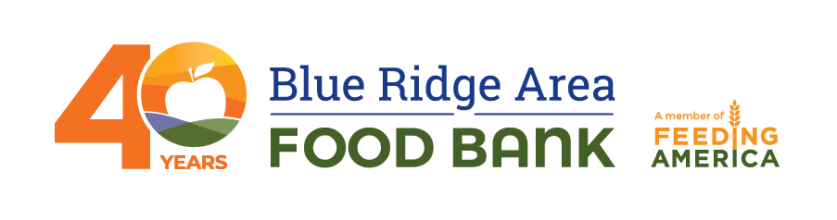
Contact:
Evans Mandes
emandes@hodgespart.com
703-677-2087

STRONGER TOGETHER: BLUE RIDGE AREA FOOD BANK
FORTIFIES PARTNER NETWORK WITH MORE THAN $2 MILLION IN GRANTS
In a historic investment, 120 Agency Capacity Fund grants were awarded in 2021
VERONA, Va. (Nov. XX, 2021) – The Blue Ridge Area Food Bank recently awarded more than $2 million in grants to 120 of its partner agencies through the organization’s Agency Capacity Fund. The amount–totaling $2,037,582–is the largest annual total awarded since this donor-driven strategy began.
Launched in 2016, the Fund supports the Food Bank’s network of more than 200 community partners with financial grants each year to invest in necessary equipment and other resources to maintain and enhance their food distribution efforts. This year’s fund was especially critical following the COVID-19 pandemic and its effects on the Food Bank’s network.
“We’re immensely proud of the impact that the Agency Capacity Fund has had on our partner network over the past five years,” said Michael McKee, CEO of the Blue Ridge Area Food Bank. “But the past 18 months truly shined a light on the pervasiveness of food insecurity across our service area. To meet the increased and sustained demand caused by the pandemic, we needed to make significant investments to allow our partners to bolster their operations, and more broadly, support our strategic initiative of improving the nutrition and health of people who need food.”
From June 2020 to July 2021, the Food Bank and its partners served an average of 118,300 people per month, distributing 28.7 million pounds of food—the equivalent of almost 24 million meals—including six million pounds of produce.

In the spring of 2021, all 207 partner food pantries, as well as 187 program-site partners, were invited to apply for awards from the Agency Capacity Fund. This year, in addition to small grants for equipment, the Food Bank also offered partners the opportunity to apply for large, capital grants for the first time. Substantial investments can help fund items like trucks and vans, contribute to pantry innovations and improvements, and even offer rent support to organizations moving to larger spaces.
As a result of the awards, the following items have been and are being distributed to Food Bank partners:
- 96 computers, tablets and other technology enhancements
- 80 coolers and freezers
- 52 supplies and space improvements
- 39 awards for shelving, pallet jacks and floor scales
- 24 capital-improvement projects and expansions
- 17 walk-in coolers and freezers
- 14 trucks and vans
McKee continued, “We would not be successful in our mission if it weren’t for the dedicated network of partners who cover our 12,000 square-mile service area. This is one of the largest investments this food bank has made in its partner network, and we consider ourselves fortunate that our generous donors entrust us with their gifts and have supported our work throughout the pandemic.”
To learn more about the Blue Ridge Area Food Bank’s Agency Capacity Fund, visit brafb.org/about-us/how-we-work/our-partners.
***
About the Blue Ridge Area Food Bank
Founded in 1981 and headquartered in Verona, Virginia, the Blue Ridge Area Food Bank is proud to mark 40 years of providing nourishing food to our neighbors in need. As the largest organization alleviating hunger in western and central Virginia, the Food Bank serves an average of nearly 119,000 individuals each month across 25 counties and eight cities through distribution centers in Charlottesville, Lynchburg, Winchester, and Verona. This 40th year is like no other: Together with our network of 207 community partners and 187 program sites, we’re serving record numbers of Virginians during a prolonged pandemic and its associated economic impacts. We pledge to continue innovating and adapting to secure, store, and distribute more food to more individuals, families, children, and seniors in need. The Food Bank is a member of Feeding America, a national food bank association that supports 200 food banks across the United States providing 6 billion meals to 42 million people through 60,000 partner pantries. For more information, visit www.brafb.org.
###

