PURPOSE
This instruction aid covers user login and password renewal and password reset.

AUDIENCE
Agency employees and volunteers who access Link2Feed

PREREQUISITES
Notification of account creation and temporary password

INSTRUCTION STEPS
- Access Link2Feed web page
- Log in to Link2Feed
- New User: Renew Password
- New user: Accept End User Licensing Agreement
- Request password reset

Revision History
Nov 19, 2018 Initial Release
Dec 1, 2022 Re-release; update Dashboard / Case Management screen

- Access Link2Feed web page
- Open web browser
HINT: The web browsers supported by Link2Feed are Google Chrome, Apple Safari and Mozilla Firefox. Do not use Microsoft Internet Explorer

- Enter  https://accounts.link2feed.com  into the web browser | 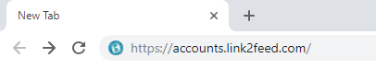

- Log in to Link2Feed
- You should now see the Login to the Portal screen
- Enter the email address used to create your user account
- Enter your password  New User: Enter the temporary password used to create your account |  | 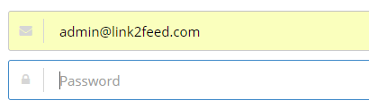
- Error message “Invalid email or password” will appear if you do not enter email and/or password correctly  Repeat steps b. and c. |  | 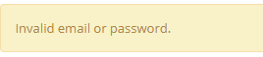
HINT: A warning will appear if you do not enter email and/or password correctly on the 2nd attempt. You will be locked out with one more failed attempt. |  | 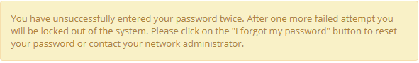
First-time users proceed to Step 3.
- Click Open in the Case Management box | 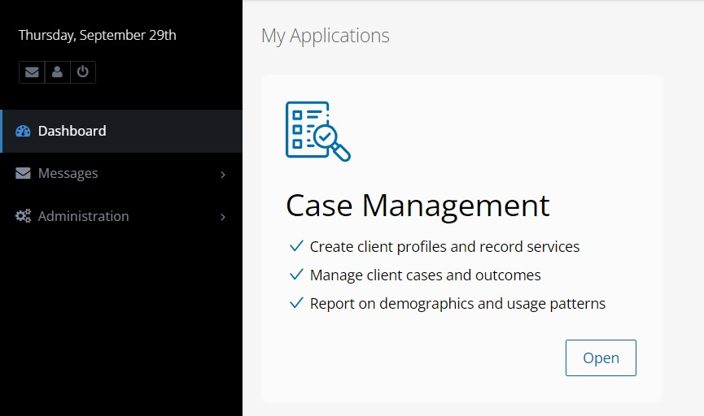

- Renew Password
- You will be requested to Renew (change) your password | 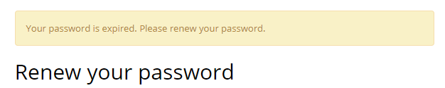
- Enter the temporary password used to create your account | 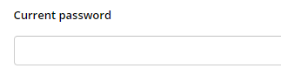
- Enter a new password in the “New Password” field. Re-enter the new password in the “confirm new password” field | 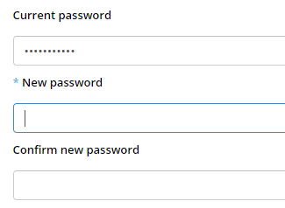
RULE: Link2Feed passwords must be:
- At least 8 characters in length
- Include on UPPERCASE letter
- Include one numeral (0-9)
- Include one special character (!,@,#,$,%,)
- Click “change My Password”

- Accept End User Licensing Agreement (EULA)
- You will be requested to accept the Link2Feed End User Licensing Agreement (EULA |  | 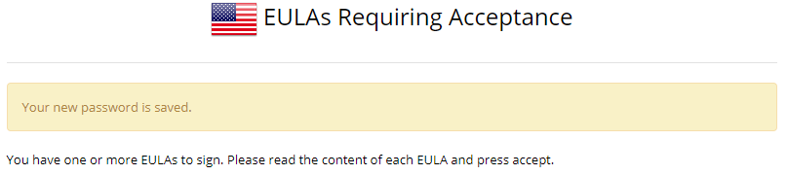
- Click the “+” at the right side of the message to expose the Agreement. |  | 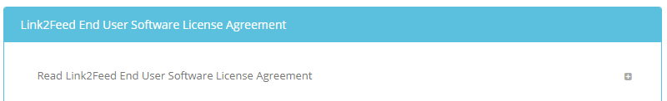
- Read the Link2Feed End User Software License Agreement.  Click the “-“ at the right side of the screen to hide the Agreement |  | 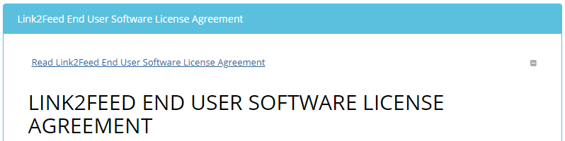
- Scroll down to the “I have read and understood….”message
- Click the box to confirm you have read and understood the agreement.
- Click “Agree”
- Click Open in the Case Management box

- Request password reset
- From the “Login to the Portal” screen
- Click “I Forgot My Password”
- You should see the “Request a Password Reset” screen |  | 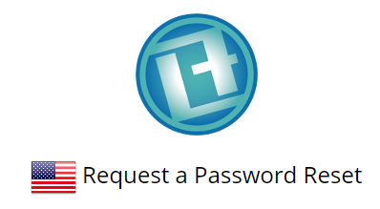
- Enter the email address on your user account
- Click “Make Request” |  | 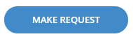
- A message titled “Reset password instructions” will be sent to the email on your user account
- Open the message and click in the “Change my password” link |  | 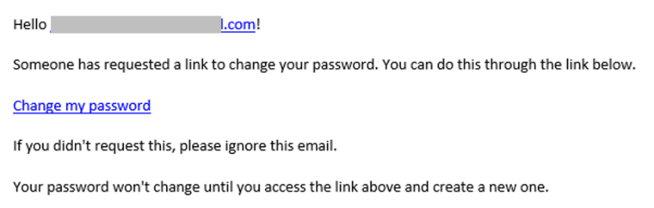
- You should now see the “Change Your Password” Portal screen |  | 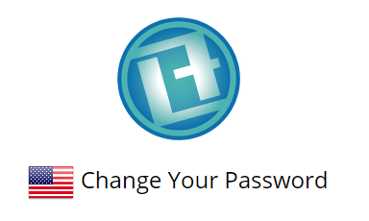
RULE: New password must be different than the current password
RULE: Link2Feed passwords must be:
- At least 8 characters in length
- Include on UPPERCASE letter
- Include one numeral (0-9)
- Include one special character (!,@,#,$,%,)
- Enter a password in the “New Password” field |  | 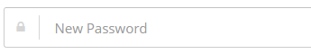
- Re-enter the password in the “New Password Again” field |  | 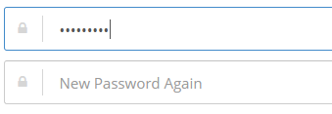
- Click the “Change My Password” button
- Click Open in the Case Management box

