PURPOSE
This instruction aid covers exception handling during selection of a client.
The exceptions that may need to be handled are:
- Switch to Primary Client (of the Household)
- Profile Review Required
- Merge Review
- Split from Household

AUDIENCE
Agency employees and volunteers who record client visits to a food pantry and who maintain or update client information

PREREQUISITES
- User Log In & Password Reset
- Search Client Record
- New Client Entry-New TEFAP
- New Client Entry-New Client

INSTRUCTION STEPS
(B) Search Client Record
- Identify the client data exception
- Resolve the client data exception

Release History
Nov 19, 2018 Initial Release
Dec 1, 2022 Re-release

- Identify the client exception
HINT: There are two types of client exceptions: “not the primary client in the household” and “profile review required”
Not the primary client in household
- A message “Click here….” will appear for a client record that is not the primary client of the household | 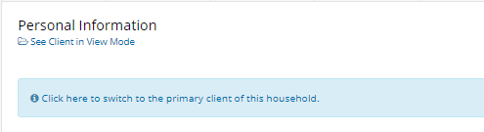
HINT: Services can be delivered for a client who is not the primary client in the household if Services tab is Green (active)
RULE: Services should only be recorded for the primary client of the household with one exception: a household member eligible for CSFP
- Click on “Click here….” to switch to the primary client of the household.

Complete Service Delivery per
(1) Service Delivery, Steps 2-7
Profile Review Required
- Client records with data exceptions will only have PERSONAL tab active; all other tabs will be shaded (not active)

- The client data exception will appear on the PERSONAL tab below “Personal Information” | 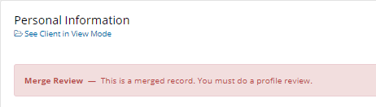
HINT: There are several types of and reasons for client data exceptions, but the steps for resolving them are the same

- Resolve the client data exception
- Click on the PERSONAL tab to view the client’s name, address and other personal information
- Review required fields to determine if any are not completed and update missing fields
HINT: The required fields that most often require updating are  *Street, City, County, State & Zip  *Referred By  *Housing Type  *Household Members Date of Birth | 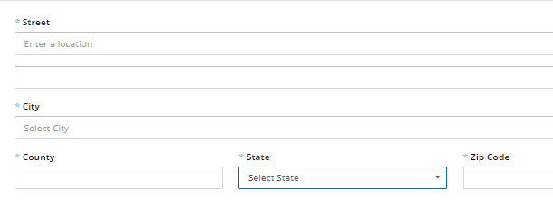  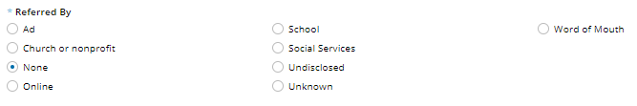
- Scroll to the bottom of the screen and click “Save & Next”
- The screen will change to MONTHLY INCOME tab.
- Review the income and programs for each member of the household and update as needed
- Scroll to the bottom of the screen and click “Save & Next”
- Scroll to the bottom of the screen and click “Save Changes”
Profile Review is complete for the client

