PURPOSE
This instruction aid covers the selection and recording of a New TEFAP, New CSFP or New Pantry Service that is delivered to an Agency client.

AUDIENCE
Agency employees and volunteers who schedule and record deliveries to clients

PREREQUISITES
- Log In & Password Reset
- Search Client Record
(D) Record Services Visit

INSTRUCTION STEPS
 | New TEFAP | New CSFP | New Pantry
PANTRIES WITH LARGE NUMBER OF WEEKLY DELIVERIES
- Create Attendance List and add clients
- Retrieve Attendance List
- Attendance: search, identify and select client record
PANTRIES WITH SMALL NUMBER OF WEEKLY DELIVERIES
- Search Client Record
ALL PANTRIES
- Services: select Service to which the client is eligible | Select a service
- Pantry Distribution: update date and Delivery Required
- Pantry Distribution: select the reason(s) for the visit
- Pantry Distribution: select the client eSignature type
- Pantry Distribution: record the proxy’s signature
- Pantry Distribution: save the record

Release History
Nov 19, 2018 Initial Release
Dec 1, 2022 Re-release

- Create Attendance List and add clients
- Select Clients from the side menu | 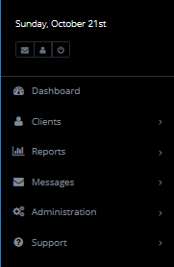
HINT: The side menu will remain visible as you navigate through Link2Feed
- Select Attendance from Clients sub-menu | 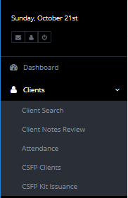
HINT: If Attendance does not appear in your side menu, contact BRAFB to request it be added to your user role.
- Click on New Attendance Group
- Enter a name for the Attendance Group | 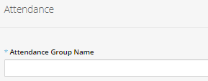
HINT: Use a name that describes the delivery date and route or location. Example: 3rd Sat Blue Route
- Search for each client that you wish to add to the delivery list and select the client record | 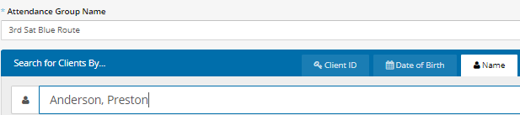
- The client record will be added to the delivery list | 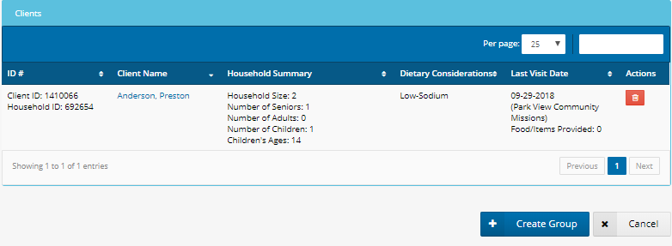
- Repeat steps e. and f. until all clients have been added. Then, click on Create Group
- Delivery List will appear in the Attendance Client Group List | 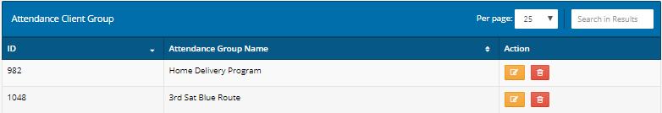

- Retrieve Attendance List
- Select Clients from the side menu
- Select Attendance from Clients sub-menu
- Delivery Lists will appear in the Attendance Client Group List.
- Find the desired list and click on the orange Edit icon

- Search, identify and select client record
- Scan for the client for whom you wish to record a delivery. Click on their name | 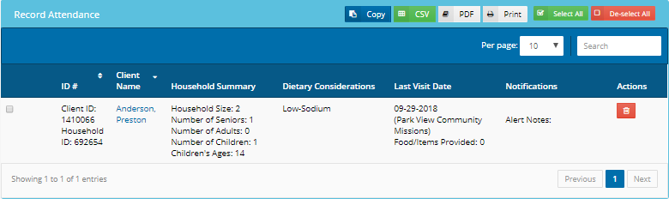
HINT: Client records can be added to or deleted from Attendance Group from “Record Attendance” screen.

- Select Service to which the client is eligible
- Click on SERVICES tab at top of page
- Eligible Services appear as Blue boxes. Click in the desired service for this visit.
RULE: Select New TEFAP Pantry for clients who receive both TEFAP and Pantry food

- Update date and Delivery Required
- Update the date (if the delivery was prior to today) and change Delivery Required to “Yes” | 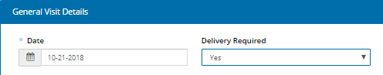

- Select the reason(s) for the visit
- Check the reason or reasons for today’s visit. If client has not stated a reason, check “Ongoing Need” | 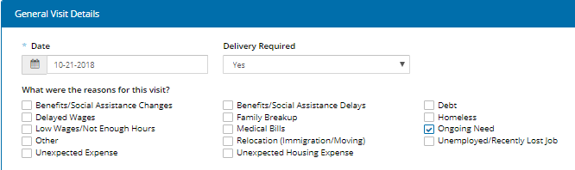
If NEW PANTRY DISTRIBUTION, skip to Step 10.
- Select the client eSignature type
- Scroll down to Client eSignature section and select Signature Type from the pulldown list
RULE: Written authorization for an alternate is required from the client to sign for TEFAP or CSFP delivery

- Record the proxy’s eSignature
Sign On Screen option
- Click on Open Signature Canvas
- You will see “Press Esc to exit full screen” for 5 seconds.
Hint: DO NOT press the Esc key when you see the message, or you will need to repeat Step 8
- Sign on the screen using a fingertip or a stylus
- Press Esc key on keyboard
ScripTel Signature Pad option
- If ScripTel Signature Pad is selected, small signature window will appear
- Use the stylus to sign the Signature Pad.
You will see the signature in the signature window as the proxy signs
HINT: Request client to click OK on the Signature Pad when done signing to clear the Signature Pad screen | 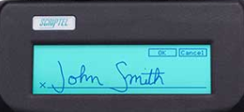
Hard Copy Signature option
- Check the “Client has Signed Hard Copy”
RULE: A hard copy client signature for the certification must have been obtained and placed on file before selecting this option.

- Save the record
All Signature Type options
- Scroll to the bottom of page and click Save
- For clients who are eligible to receive a second Service, Repeat Steps 5-10 | 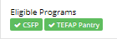
RULE: Record two services for TEFAP clients who also receive CSFP and for CSFP clients who also receive Pantry food

