PURPOSE
This instruction aid covers exception handling during selection and recording of a New TEFAP or New CSFP Visit to a client.
The exceptions that may need to be handled are:
- TEFAP requires certification or recertification
- CSFP requires certification or recertification
- Client has already received TEFAP today
- Client has already received CSFP this month

AUDIENCE
Agency employees and volunteers who record client visits to a food pantry

PREREQUISITES
- Log In & Password Reset
- Search Client Record
- Record Services Visit
(K) Modify Client CSFP Status

INSTRUCTION STEPS
 | New TEFAP | New CSFP | New Pantry
- Search Client Record
- Services: Identify an eligibility exception
- TEFAP or CSFP: Resolve eligibility exception
- TEFAP or CSFP: select the client eSignature type
- TEFAP or CSFP: obtain the client eSignature
- TEFAP or CSFP: save the record
- Services: Identify a duplicate visit exception

Release History
Nov 19, 2018 Initial Release
Dec 1, 2022 Re-release

- Identify an eligibility exception
- “Recertification Required” will appear in a banner at the top of the screen if the client is eligible for service but their certification has expired | 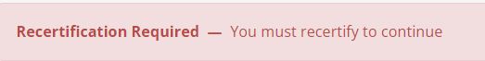

- Resolve the eligibility exception
TEFAP
- Click on TEFAP tab at top of page | 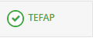
- TEFAP Client Info screen will appear | 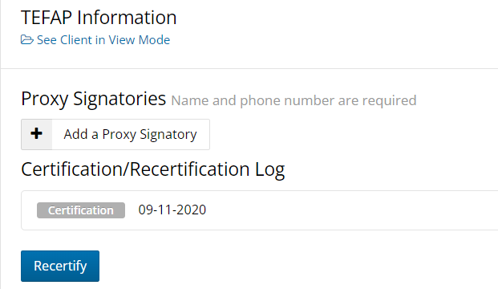
- Click “Recertify”
- Proceed to Step 5
CSFP
Proceed to (K) Modify Client CSFP Status, Step 2

- Select the client eSignature type
- Scroll down to Client eSignature section and select Signature Type from the pulldown list

- Obtain the client eSignature
Sign On Screen option
- Click on Open Signature Canvas
- You will see “Press Esc to exist full screen for 5 seconds”.
Hint: DO NOT press the Esc key when you see the message, or you will need to repeat Step 8
- Request the client sign on the screen using their fingertip
- When the client has completed their signature, press Esc key on keyboard
ScripTel Signature Pad option
- If ScripTel Signature Pad is selected, small signature window will appear
- Request the client use the stylus to sign the Signature Pad.
You will see the signature in then signature window as the client signs
HINT: Request client to click OK on the Signature Pad when done signing to clear the Signature Pad screen | 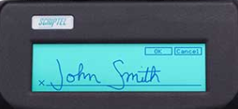
Hard Copy Signature option
- Check the “Client has Signed Hard Copy”
RULE: A hard copy client signature for the certification must have been obtained and placed on file before selecting this option.

- Save the record
All Signature Type options
- Scroll to the bottom of page and click Save

- Identify a duplicate visit exception
- Click on SERVICES tab at top of page | 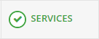
HINT: Last visit to your pantry will appear on the right side of the screen | 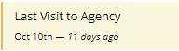
HINT: Scroll down to view list of past visits to your pantry. This will help avoid a Duplicate Visit Exception | 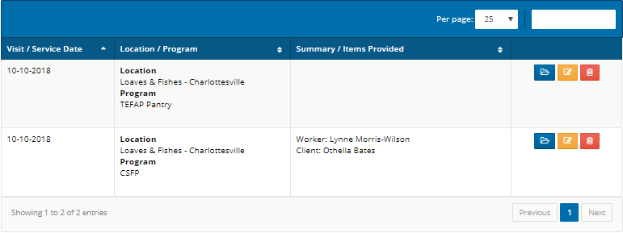
TEFAP
- TEFAP Services button will not show that a visit has been recorded in the month
- If you select the TEFAP Service and a TEFAP has already been provided on the same day, an error message will appear in the upper right corner of the screen | 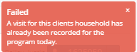
- And a message will appear at the bottom of the Household Summary  Inform the client that a visit has already been recorded for the Service today. | 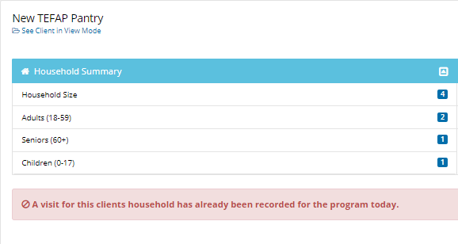
- Click “Back to Services” to select another eligible Service

CSFP
- CSFP Services button will show that a visit has been recorded in the month
- If you select the CSFP Service, an error message will appear in the upper right corner of the screen | 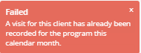
- And a message will appear at the bottom of the Household Summary  Inform the client that a visit has already been recorded for the Service today. | 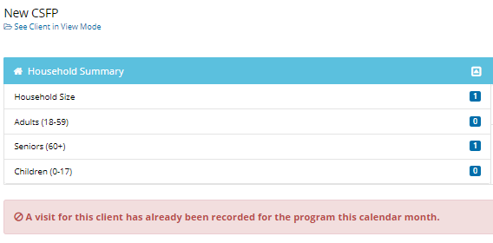
- Click “Back to Services” to select another eligible Service
Pantry
- New Pantry Services button will not show that a visit has been recorded in the month
- If you select the TEFAP Service and a TEFAP has already been provided on the same day, an error message will appear in the upper right corner of the screen
- And a message will appear at the bottom of the Household Summary.  Inform the client that a visit has already been recorded for the Service today. | 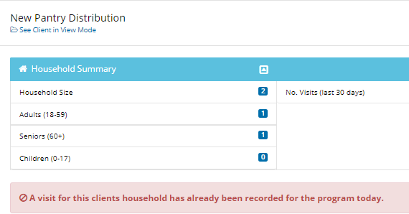
- Click “Back to Services” to select another eligible Service

