PURPOSE
This instruction aid covers adding a new client record, either from a paper form or in person, for an agency that offers USDA TEFAP.

AUDIENCE
Agency employees and volunteers who perform client intake for a food pantry or who enter client data as part of Link2Feed implementation

PREREQUISITES
- User Log In & Password Reset
- Search Client Record

INSTRUCTION STEPS
(B) Search Client Record
- Add new record
- Perform TEFAP Screening
- Enter Client Personal information
- Update Household Members
- Enter Monthly Income information

Release History
Nov 19, 2018 Initial Release
Dec 1, 2022 Re-release

- Add new record
- Click New TEFAP
RULE: New TEFAP is required for in-person clients by Virginia Department of Agriculture and Consumer Services (VDACS) to establish TEFAP eligibility before collecting remaining info

- Perform TEFAP Screening
- Enter client Last Name and First Name. Confirm spelling with client. | 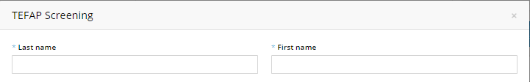
HINT: Names should have first letter capitalized and all other letters in lower case
HINT: Suffix (Jr, III) should be at end of Last Name with no punctuation
HINT: Last Names may be two names and may or may not be hyphenated.
- Begin typing client Address in Address line 1 | 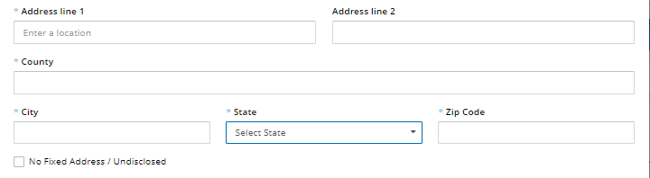
- A list of address choices will appear. Continue typing until the correct address appears in the list. Confirm address with client | 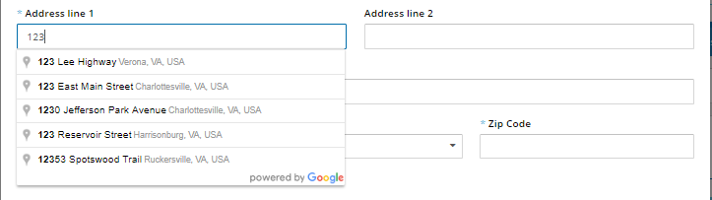
- Select the correct address. The software will auto-fill the county, city, state and zip code fields | 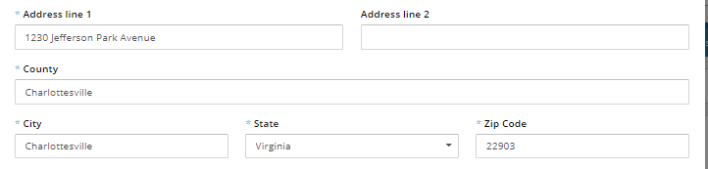
- Enter apartment or unit in “Address Line 2”, if applicable
HINT: If the client does not have an address or declines to disclose their address, click “No fixed address / Undisclosed” | 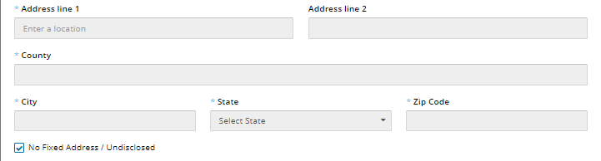
- Enter total number of people in the Household including the primary client  - Enter the estimated monthly income for all members of the Household | 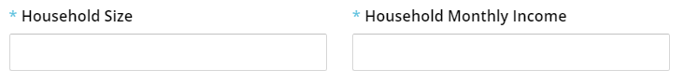
- Click the Social Programs that apply for the Household | 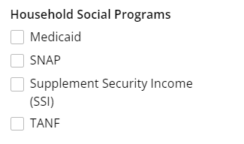
- Read disclaimer to client before asking them to sign
- Scroll down to Client eSignature section and select Signature Type from the pulldown list
Sign On Screen option
- Click on Open Signature Canvas
- You will see “Press Esc to exit full screen” for 5 seconds.
Hint: DO NOT press the Esc key when you see the message, or you will need to repeat Step g.
- Request the client sign on the screen using a fingertip or stylus
- When the client has completed their signature, press Esc key on keyboard

ScripTel Signature Pad option
- If ScripTel Signature Pad is selected, small signature window will appear
- Request client use the stylus to sign the Signature Pad.
You will see the signature in the signature window as the client signs
HINT: Request client to click OK on the Signature Pad when done signing to clear the Signature Pad screen | 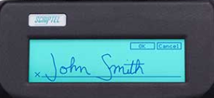
Hard Copy Signature option
- Check the “Client has Signed Hard Copy”
RULE: A hard copy client signature for the certification must have been obtained and placed on file before selecting this option.
All Signature Type options
- Scroll to the bottom of page and click Confirm Eligibility
- TEFAP eligibility message “TEFAP Eligible” or TEFAP Ineligible” will appear.  Inform client of eligibility by reading the message text | 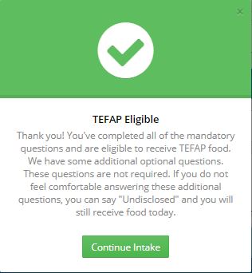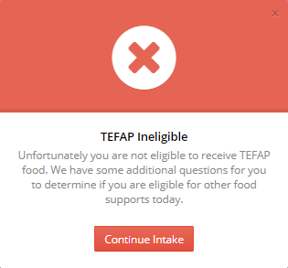
- Click Continue Intake

- Enter Client Personal information
- Personal Information screen will display a reminder that client profile must be created within 72 hours | 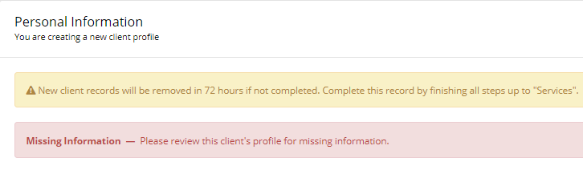
HINT: Required fields are marked with an asterisk (*). They must be completed before pressing “Save & Next” or an error message will appear at the top of the screen
- Select one value for “First Food Bank Visit” from list of choices | 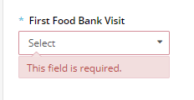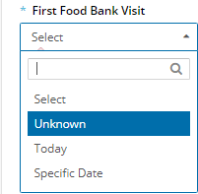
HINT: Select “Unknown” for existing client whose data is being entered from paper records
- Client Last Name and First Name that were entered in TEFAP screening will be visible

- Enter Date of Birth using format MM-DD-YYYY | 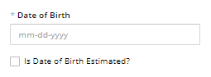
HINT: If Date of Birth is not known, estimate YYYY from person’s age, enter 01-01-YYYY and check “Is Date of Birth Estimated?” | 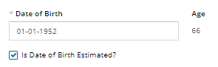
- Select one value from list of choices | 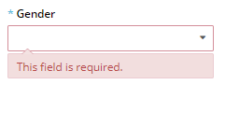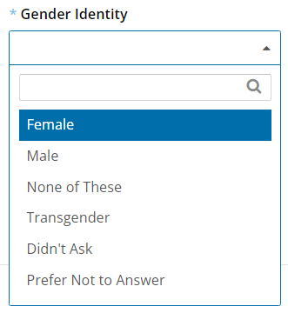
- Scroll down to Marital Status. Select one value from list of choices | 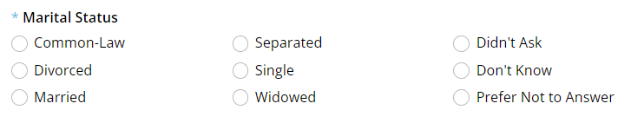
- Scroll down to Housing Type. Select one value from list of choices | 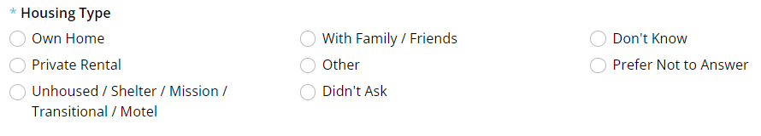
- Scroll down to ID Type. Click “ADD” if an ID is required to obtain Services | 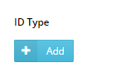
RULE: An ID is only required for clients over the age of 60 who wish to receive CSFP
- Select one value from list of choices | 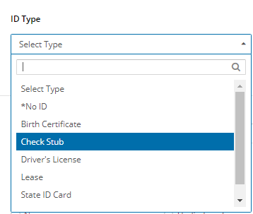
- Verify ID and enter your initials in the Confirmation field | 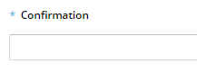
RULE: ID numbers shall not be recorded in the Confirmation field
- Scroll down to Languages. Click on the appropriate values from the list of choices | 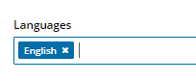
- Scroll down to “Referred By”. Select one value from list of choices | 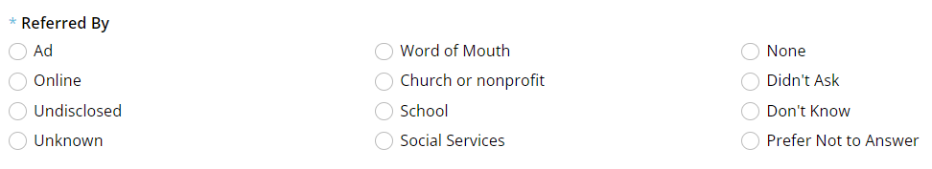
- Scroll down to “Ethnicity”. Click on the appropriate values for from the list of choices | 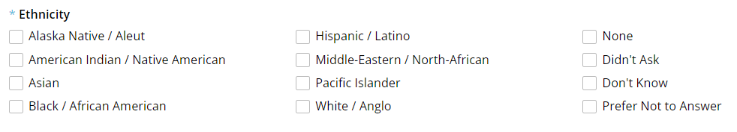
HINT: Clients may self-identify as more than one Ethnicity type | 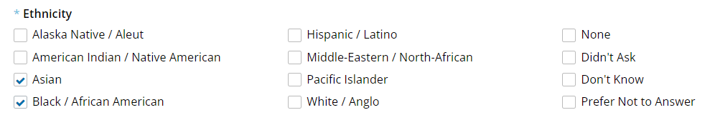
- Scroll down to “Self-Identifies As”. Click on the appropriate values from the list of choices
If there are Household Members, proceed to Step 5.
Otherwise, Jump to Step 6.
- Scroll to the bottom of the screen and click “Save & Next”

- Update Household Members
- Scroll down to Household Members. “Anonymous Client” records will have been created from Household Size entered in TEFAP Screening | 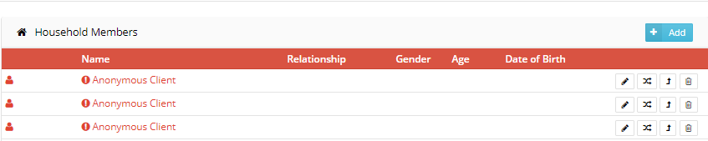
- Click on the Edit icon (pencil) for an “Anonymous Client” record
- Enter Last Name and First Name in Household Member info | 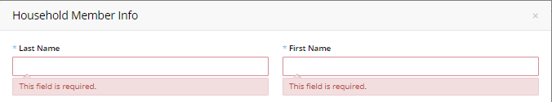
- Enter Date of Birth using format mm/DD/YYYY or MM-DD-YYYY
HINT: If Date of Birth is not known, estimate YYYY from person’s age, enter 01-01-YYYY and check “Is Date of Birth Estimated”
- Select one Gender value from list of choices
- Select one Relationship value from list of values | 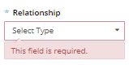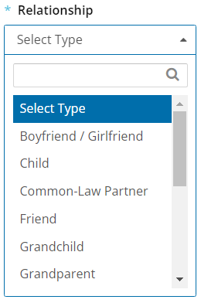
- Scroll down to “Ethnicity”. Click on the appropriate values for from the list of choices
- Scroll down to “Self-Identifies As”. Click on the appropriate values from the list of choices
- Scroll to the bottom of the screen and click “Changes”
- Repeat Steps a. through g. for each “Anonymous Client” record | 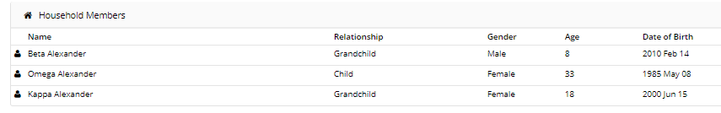
HINT: Anonymous Client records must be completed or deleted before pressing “Save & Next” or an error message will appear at the top of the screen
- Click “Save & Next”

- Enter Monthly Income information
- The screen will change to MONTHLY INCOME tab. | 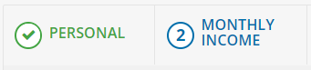
- Monthly Income and Expenses screen will display a reminder that client profile must be created within 72 hours | 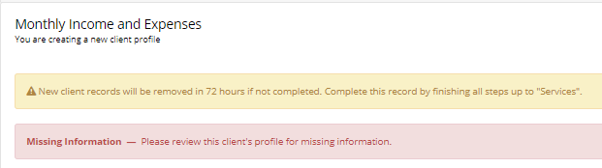
- Scroll down to “Household Social Programs”. Values selected during TEFAP qualification will be populated | 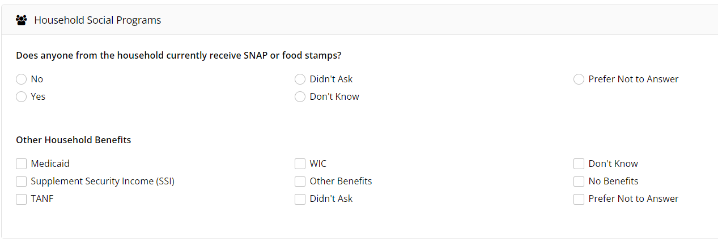
- Scroll down to “Monthly Income”. Re-enter the total monthly income from TEFAP qualification | 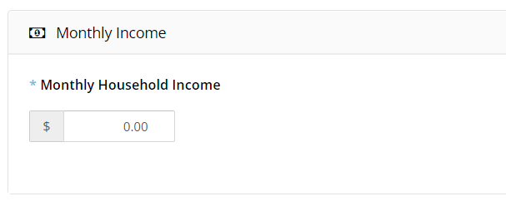
NOTE: Monthly Income is NOT populated from TEFAP qualification screen
HINT: Monthly Household Expenses is an option available to agencies that do case management with their clients. | 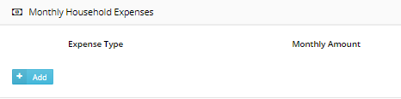
- Review the income and programs for each member of the household and update as needed
- Click “Save Changes”
New TEFAP Entry is Complete

