PURPOSE
This instruction aid covers adding a new client record, either from a paper form or in person, for an agency that does not offer TEFAP.

AUDIENCE
Agency employees and volunteers who perform client intake for a food pantry or who enter client data as part of Link2Feed implementation

PREREQUISITES
- User Log In & Password Reset
- Search Client Record

INSTRUCTION STEPS
(B) Search Client Record
- Add new record
- Enter Client Personal information
- Add Household Members
- Enter Monthly Income information

Release History
Nov 19, 2018 Initial Release
Dec 1, 2022 Re-release

- Add new record
- Click New Client

- Enter Client Personal information
- Personal Information screen will display a reminder that client profile must be created within 72 hours | 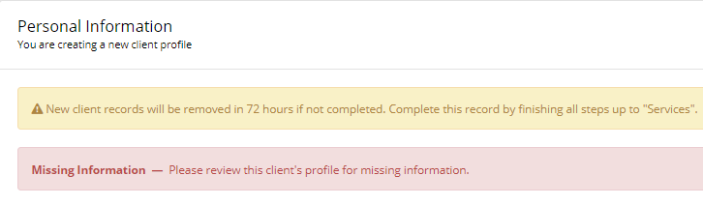
HINT: Required fields are marked with an asterisk (*). They must be completed before pressing “Save & Next” or an error message will appear at the top of the screen
- Select one value for “First Food Bank Visit” from list of choices | 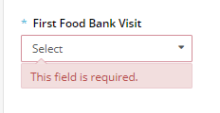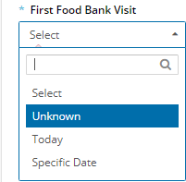
HINT: Select “Unknown” for existing client whose data is being entered from paper records
- Enter client Last Name and First Name | 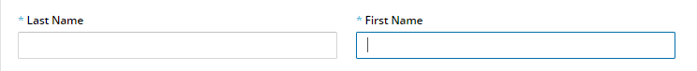
HINT: Names should have first letter capitalized and all other letters in lower case
HINT: Suffix (Jr, III) should be at end of Last Name with no punctuation
HINT: Last Names may be two names and may or may not be hyphenated.
- Enter Date of Birth using format MM/DD/YYYY or MM-DD-YYYY | 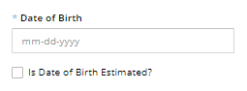
HINT: If Date of Birth is not known, estimate YYYY from person’s age, enter 01-01-YYYY and check “Is Date of Birth Estimated?” | 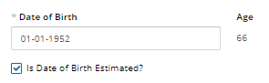
- Select one value from list of choices | 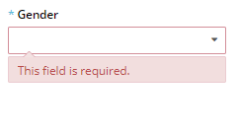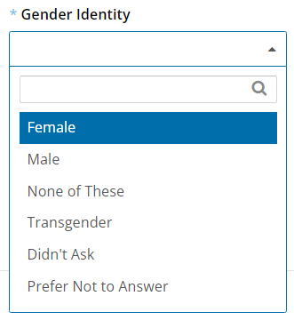
- Scroll down to Marital Status. Select one value from list of choices
- Scroll down to Address line 1. Begin typing client Address in Address line 1 | 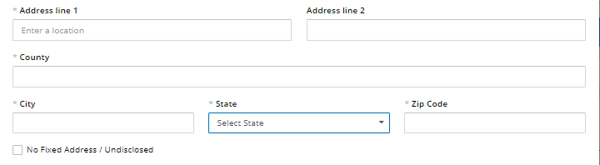
- A list of address choices will appear. Continue typing until the correct address appears in the list | 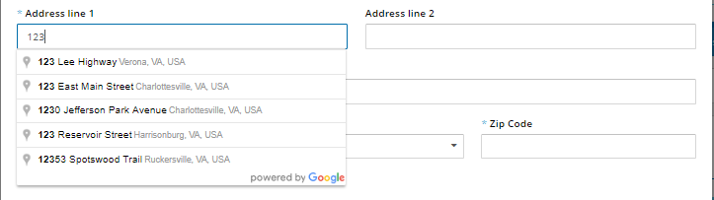
- Select the correct address. The software will auto-fill the county, city, state and zip code fields | 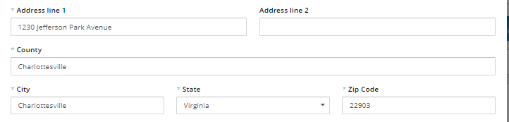
- Enter apartment or unit in “Address Line 2”, if applicable
HINT: If the client does not have an address OR declines to disclose their address, click “No fixed address / Undisclosed” | 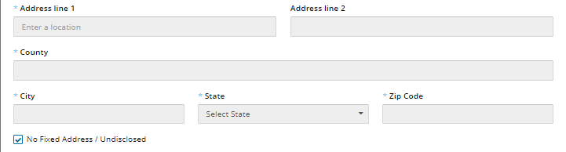
- Scroll down to Housing Type. Select one value from list of choices | 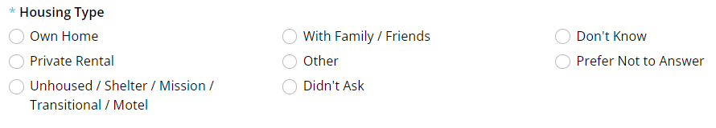
- Scroll down to ID Type. Click “ADD” if an ID is required to obtain Services | 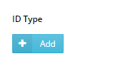
RULE: An ID is only required for clients over the age of 60 who wish to receive CSFP
- Select one value from list of choices | 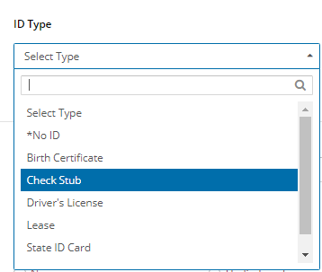
- Verify ID and enter your initials in the Confirmation field | 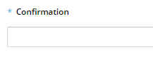
RULE: ID numbers shall not be recorded in the Confirmation field
- Scroll down to Languages. Click on the appropriate values from the list of choices | 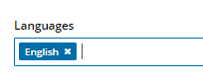
- Scroll down to “Referred By”. Select one value from list of choices | 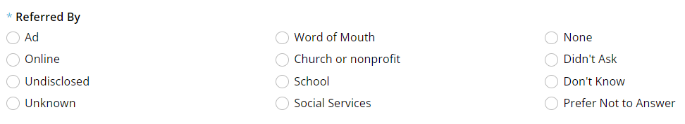
- Scroll down to “Ethnicity”. Click on the appropriate values for from the list of choices
HINT: Clients may self-identify as more than one Ethnicity type | 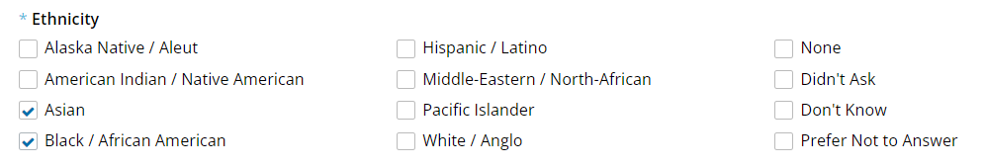
- Scroll down to “Self-Identifies As”. Click on the appropriate values from the list of choices
If there are no Household Members, Jump to Step 5
- Scroll to the bottom of the screen and click “Save & Next”
- Add Household Members
- Scroll down to Household Members
- Click Add
- Enter Last Name and First Name in Household Member info | 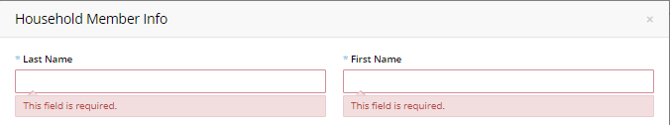
- Enter Date of Birth using format MM/DD/YYYY or MM-DD-YYYY
HINT: If Date of Birth is not known, estimate YYYY from person’s age, enter 01-01-YYYY and check “Is Date of Birth Estimated”
- Select one Gender value from list of choices
- Select one Relationship value from list of choices | 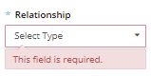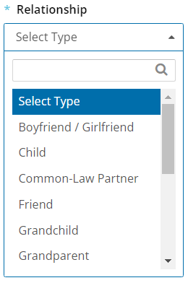
- Scroll down to “Ethnicity”. Click on the appropriate values from the list of choices
- Scroll down to “Self-Identifies As”. Click on the appropriate values from the list of choices
- Scroll to the bottom of the screen and click “Changes”
- Repeat Steps b. through g. for each Household Member | 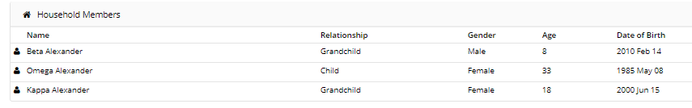
- Scroll to the bottom of the screen and click “Save & Next”

- Enter Monthly Income information
- The screen will change to MONTHLY INCOME tab.
- Monthly Income and Expenses screen will display a reminder that client profile must be created within 72 hours | 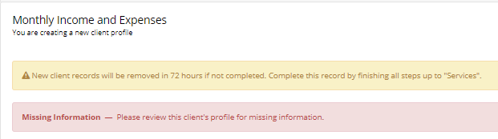
- Scroll down to “Household Social Programs”. Click on the appropriate values from the list of choices for the Household | 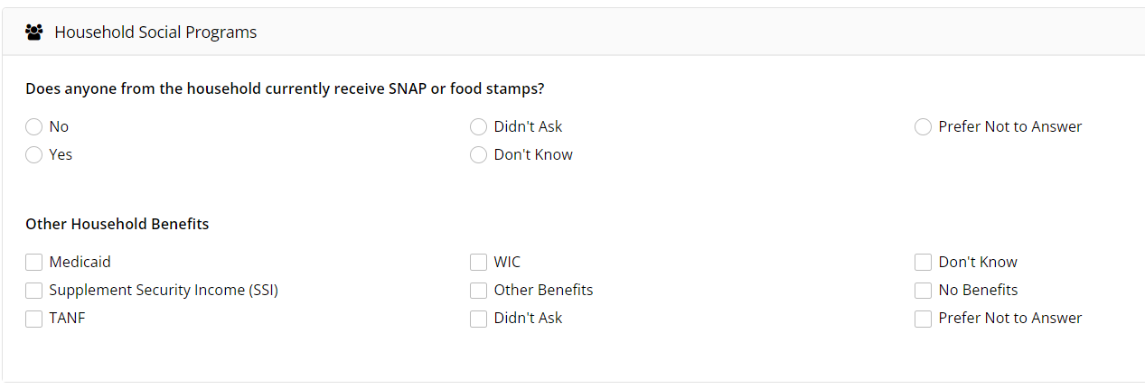
NOTE: Client is eligible for TEFAP if SNAP = Yes OR Medicaid, SSI or TANF are checked
- Scroll down to “Monthly Income”. Enter the total monthly income for the Household | 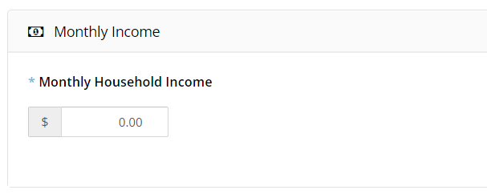
NOTE: Monthly Income should be entered IF SNAP = No AND No Household Social Programs are checked
HINT: Monthly Household Expenses is an option available to agencies that do case management with their clients. | 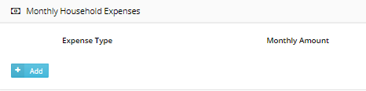
- Review the income and programs for each member of the household and update as needed
- Click “Save Changes”
New Client Entry is Complete

