PURPOSE
This instruction aid covers TEFAP Certification after adding a New TEFAP client or during a Service Visit for an existing client.

AUDIENCE
Agency employees and volunteers who perform client intake for a food pantry or who enter client data as part of Link2Feed implementation

PREREQUISITES
(A) Log In & Password Reset
(G) New Client Entry-New TEFAP

INSTRUCTION STEPS
(B) Search Client Record
- TEFAP: Complete TEFAP Certification
- TEFAP: select the client eSignature type
- TEFAP: obtain the client eSignature
- TEFAP: save the record
- TEFAP: Review Certification Log

Release History
Nov 19, 2018 Initial Release
Dec 1, 2022 Re-release

- Complete TEFAP Certification
- Click on TEFAP tab at top of page
- TEFAP Client Info screen will appear | 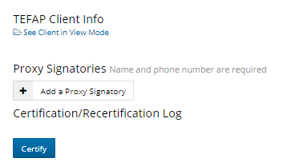
HINT: A proxy is someone authorized by the client to obtain Services and provide an eSignature on the client’s behalf
If client does not name a Proxy, Skip to step e.
- If client wants to authorize a proxy, click “Add a Proxy Signature”.
- Enter the Name and Phone Number of the Proxy. | 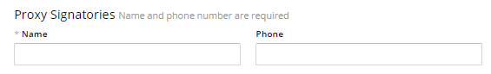
- Click either “Certify” or “Recertify” (only one button will be present) | or

- Select the client eSignature type
- Scroll down to Client eSignature section and select Signature Type from the pulldown list

- Obtain the client eSignature
Sign On Screen option
- Click on Open Signature Canvas
- You will see “Press Esc to exit full screen” for 5 seconds.
Hint: DO NOT press the Esc key when you see the message, or you will need to repeat Step 3
- Request the client sign on the screen using their fingertip
- When the client has completed their signature, press Esc key on keyboard
ScripTel Signature Pad option
- If ScripTel Signature Pad is selected, small signature window will appear
- Request client use the stylus to sign the Signature Pad.
You will see the signature in the signature window as the client signs
HINT: Request client to click OK on the Signature Pad when done signing to clear the Signature Pad screen | 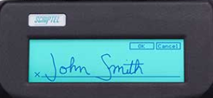
Hard Copy Signature option
- Check the “Client has Signed Hard Copy”
RULE: A hard copy client signature for the certification must have been obtained and placed on file
All Signature Type options
- Scroll to the bottom of page and click Save

- Review Certification/Recertification Log
- The Certification or Recertification and the date will appear on the log | 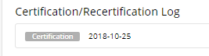  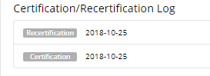
TEFAP Certification complete
Proceed with (D) Record Services Visit or (E) Services Delivery

