PURPOSE
This instruction aid covers CSFP Certification after adding a New CSFP client or during a Service Visit for an existing client.

AUDIENCE
Agency employees and volunteers who perform client intake for a food pantry or who enter client data as part of Link2Feed implementation

PREREQUISITES
(A) Log In & Password Reset
(G) New Client Entry-New TEFAP
OR
(H) New Client Entry-New Pantry

INSTRUCTION STEPS
(B) Search Client Record
- CSFP: Complete CSFP Certification
- CSFP: select the client eSignature type
- CSFP: obtain the client eSignature
- CSFP: save the record
- CSFP: Review Certification Log

- Complete CSFP Certification
- Click on CSFP tab at top of page
- CSFP Client Info screen will appear | 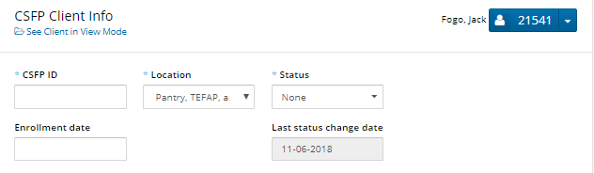
- Enter the Client ID in the CSFP ID field
HINT: Client ID appears in the blue box to the right of the Client Last Name, First Name
- The Location will default to the Agency you selected at login. | 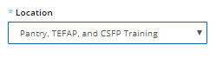
- Select Status “Active” or “Waiting List” from the list of choices | 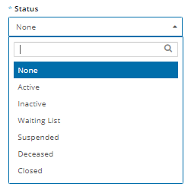
HINT: Select “Active” if your agency has CSFP Senior boxes available.  Select “Waiting List” if your agency has reached their prescribed CSFP Senior box caseload. | 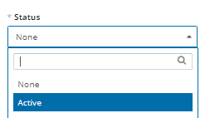
- Enter Enrollment Date
HINT: Enrollment Date is a required field and usually the date you are entering CSFP Certification
- Scroll down to Proxy Signatories
HINT: A proxy is someone authorized by the client to obtain Services and provide an eSignature on the client’s behalf
If client does not name a Proxy, Skip to step j.
- If client wants to authorize a proxy, click “Add a Proxy Signature”.
- Enter the Full Name and Phone Number of the Proxy. | 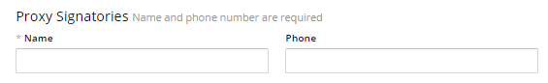
- Click either “Certify” or “Recertify” (only one button will be present)
- Read disclaimer to client before asking them to sign

- Select the client eSignature type
- Scroll down to Client eSignature section and select Signature Type from the pulldown list

- Obtain the client eSignature
Sign On Screen option
- Click on Open Signature Canvas
- You will see “Press Esc to exit full screen” for 5 seconds.
Hint: DO NOT press the Esc key when you see the message, or you will need to repeat Step 3
- Request the client sign on the screen using their fingertip
- When the client has completed their signature, press Esc key on keyboard
ScripTel Signature Pad option
- If ScripTel Signature Pad is selected, small signature window will appear
- Request client use the stylus to sign the Signature Pad.
You will see the signature in the signature window as the client signs
HINT: Request client to click OK on the Signature Pad when done signing to clear the Signature Pad screen | 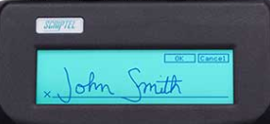
Hard Copy Signature option
- Check the “Client has Signed Hard Copy”
RULE: A hard copy client signature for the certification must have been obtained and placed on file before selecting this option.
All Signature Type options
- Scroll to the bottom of page and click Save

- Review Certification/Recertification Log
- The Certification or Recertification and the date will appear on the log | 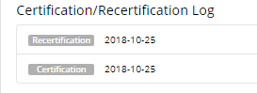
CSFP Certification complete
Proceed with (D) Services Visit or Topic: (E) Services Delivery

