PURPOSE
This instruction aid covers changing Household Members association to a Primary Client’s household.
The changes that may need to be handled are:
- Make Household Member the Primary Client (of the Household)
- Split Household Member from the household
- Add Household Member to the household
- Link Household Member from another household

AUDIENCE
Agency employees and volunteers who record client visits to a food pantry and who maintain or update client information

PREREQUISITES
- Log In & Password Reset
- Search Client Record
(C) Client Data Exceptions
(G) New Client Entry-New TEFAP OR (H) new Client Entry-New Client

INSTRUCTION STEPS
(B) Search client record
- Select Household Member
2a. Edit Basic Information
2b. Switch to Client’s Full Profile
2c. Promote to Head of Household
2d. Remove from Household

RULE: You must select the Primary Client record first before changing a Household Member’s association
- Select Household Member
- Scroll down to Household Members
- Identify the desired Household Member | 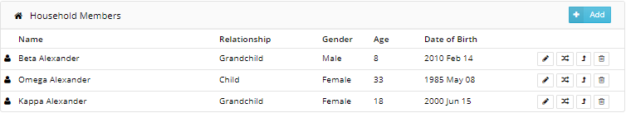
HINT: There are four actions available:
- Edit Basic Information
- Switch to Full Profile
- Promote to Head of Household
- Remove from Household

2a. Edit Basic Information
- Select and click on the Pen icon
- Edit Last Name and/or First Name in Household Member info | 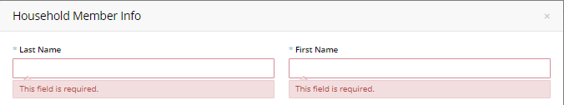
- Edit Date of Birth using format MM/DD/YYYY or MM-DD-YYYY | 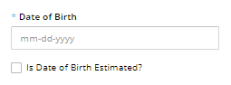
- Edit Gender by selecting one value from list of choices | 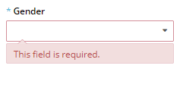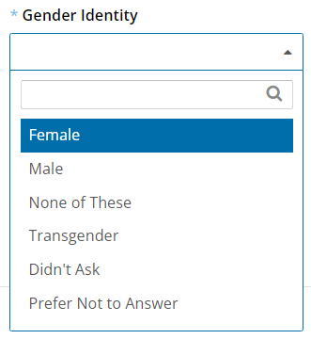
- Edit Relationship by selecting one value from list of choices | 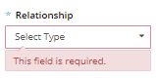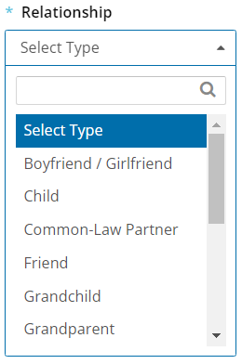
- Scroll down to “Ethnicity”. Edit by clicking on the appropriate values from the list of choices | 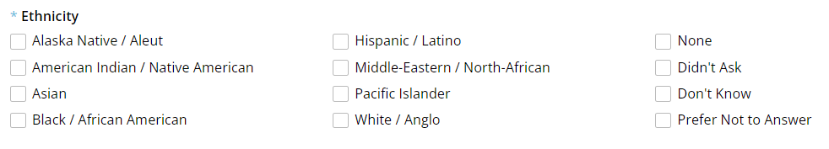
- Scroll down to “Self-Identifies As”. Edit by clicking on the appropriate values from the list of choices
- Scroll to the bottom of the screen and click “Save Changes”
Edit Basic Information Complete

2b. Switch to Client’s Full Profile
HINT: Select this option to provide Services for a CSFP-eligible client that is a Household Member | 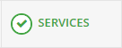
HINT: Select this option to update a Household Member’s Personal or Monthly Income information | 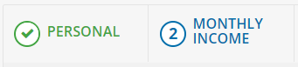
- Select and click on the Switch icon
Proceed to (D) Record Service Visit or TOPIC: (H) New Client Entry

2c. Promote to Head of Household
- Select and click on the Up-Arrow icon
- A “Promote Household Member” warning message will appear. | 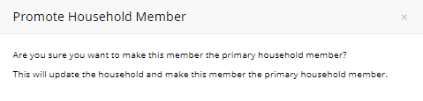
- If you are sure you want to proceed, click “Apply”.
- A “Success” message will appear confirming the person has been promoted to Primary Client | 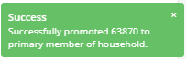
Proceed to TOPIC: (C) Client Data Exceptions

2d. Remove from Household
- Select and click on the Trash Can icon
- A “Remove Member from Household” warning message will appear. | 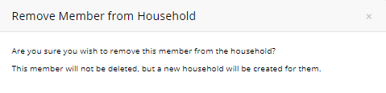
- If you are sure you want to proceed, click “Remove from Household”.
- A “Success” message will appear confirming the person has been removed from the Household | 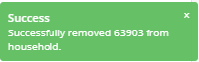
- Click “Save Changes”
Remove from Household Complete
Proceed to (C) Client Data Exceptions (for person removed from Household)

