PURPOSE
This instruction aid covers creating, editing and deleting client notes and alerts. Notes may be added during client visits or when a client record is created or updated.

AUDIENCE
Agency employees and volunteers who record client visits to a food pantry

PREREQUISITES
- User Log In & Password Reset
- Search Client Record
- Record Service Visit

INSTRUCTION STEPS
 | New TEFAP | New CSFP | New Pantry
(B) Search Client Record
- Create a Note from Notes tab
- Create an Alert from Notes tab
- Create a Note from the Services tab
- Create an Alert from the Services tab
- Edit or Delete a Note

Revision History
Nov 19, 2018 Initial Release
Dec 2, 2022 Re-release; update Dashboard / Case Management screen

- Create a Note from the Notes tab
- Click on NOTES tab at top of page | 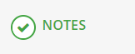
- Select “New Note” on the right side of the page
- Enter the note text in the comment box
- Select Save
- The note will appear in the Notes screen | 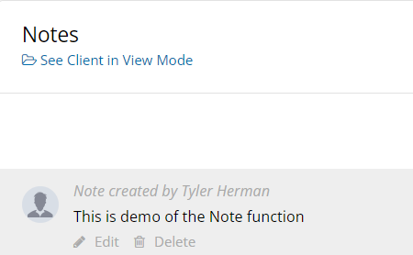

- Create an Alert from the Notes tab
- Click on NOTES tab at top of page
- Select “New Note” on the right side of the page
- Enter the note text in the comment box
- Click “Mark this note as an alert” if you want it to appear on the client Personal screen | 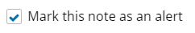
- Click “Mark this note as private” unless the Alert text applies to other pantries
RULE: Alerts for your agency should be marked as Private. Otherwise, everyone who searches for the client record will see the Alert
- Select Save
- The Alert will appear in the Notes screen AND at the top of every screen of the client’s record | 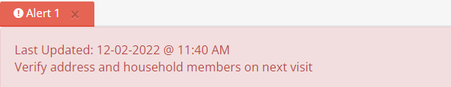  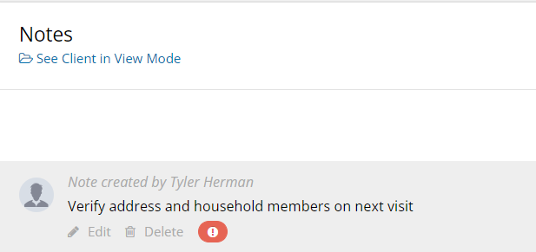

- Create a Note from the Services tab
- Click on SERVICES tab at top of page | 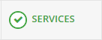
- Eligible Services appear as Blue boxes. Click in the desired service for this visit.
- Check the reason or reasons for today’s visit. If client has not stated a reason, check “Ongoing Need” | 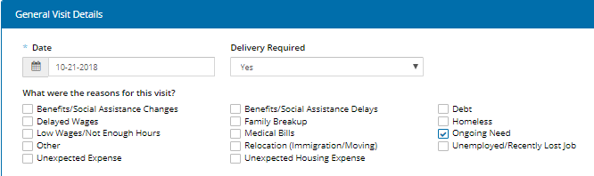
- Scroll down to “Additional Notes/Information”
- Enter the note text in the comment box
- Select Save
- The note will appear in the Notes screen | 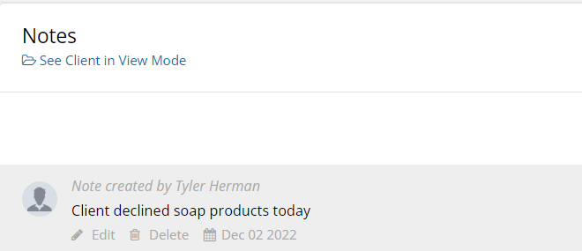

- Create an Alert from the Services tab
- Click on SERVICES tab at top of page
- Eligible Services appear as Blue boxes. Click in the desired service for this visit.
- Check the reason or reasons for today’s visit. If client has not stated a reason, check “Ongoing Need”
- Scroll down to “Additional Notes/Information”
- Enter the note text in the comment box
- Click “Mark this note as an alert” if you want it to appear on the client Personal screen
- Click “Mark this note as private” unless the Alert text applies to other pantries
RULE: Alerts for your agency should be marked as Private. Otherwise, everyone who searches for the client record will see the Alert
- Select Save
- The Alert will appear in the Notes screen AND at the top of every screen of the client’s record

- Edit or Delete a Note
HINT: Notes and Alerts should be
deleted as soon as the reason has
been addressed
- Click on NOTES tab at top of page
- Select the Note to be edited or deleted
EDIT
- Select the Edit button
- Enter the note text in the comment box
- Select Save
EDIT
- Select the Delete button
- Confirm you want to delete the note  NOTE: This a permanent action that  cannot be undone | 