PURPOSE
This instruction aid covers creating and running reports for an Agency.

AUDIENCE
Agency employees and volunteers who report and/or analyze pantry activity and results.
NOTE: The “Reporter” role must be enabled for a user to access Reports.

PREREQUISITES
“Reporter” role enabled in User’s Profile
(A) Log In & Password Reset

INSTRUCTION STEPS
- Create New Report
- View Report
- Refresh Report
- Print Report
- Export Report Data
- Delete Report

- Create New Report
- Select Reports from the side menu | 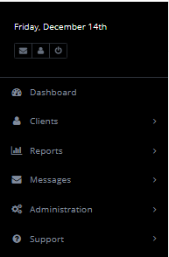
HINT: The side menu will remain visible as you navigate through Link2Feed
- Select New Report from Programs sub-menu | 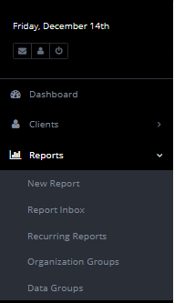
- Select the Report type you wish to create | 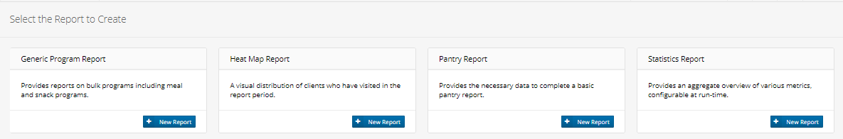
HINT: Pantry Report provides basic Pantry services information. Statistics Report provides more comprehensive Pantry services information. Generic Program Report is for Bulk Program Services (Soup Kitchen) information.

Pantry Report
- Click on New Report in the Pantry Report box
- Enter a Title for the report that will make it easy to identify in the Report Inbox | 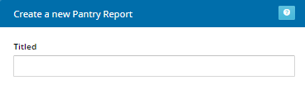
- Click “shared with people...” if you want other Link2Feed users in your pantry to see the report.
You may choose for the report to be launched either on demand or on a schedule.
If you wish to launch the report on demand, skip to Step f.
- To launch the report on a schedule, select the schedule frequency from the list of choices | 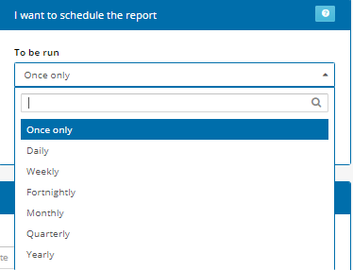
- Select the date and time when the schedule should begin | 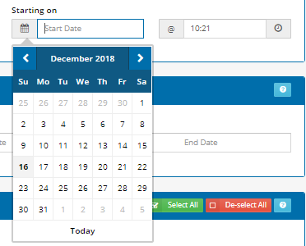
- Define the time period, either from the list of values in “What I Choose” or by entering a specific Start Date and End Date | 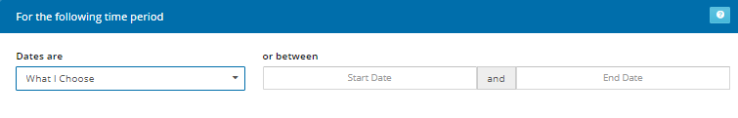  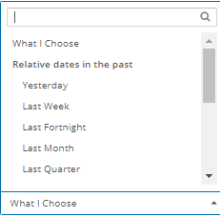
HINT: The report can be re-used in subsequent weeks or months if you select a value from “What I Choose”
- Select the data population by clicking on the appropriate parameter.  The choices are the entire pantry, certain counties or certain cities within the pantry’s service area | 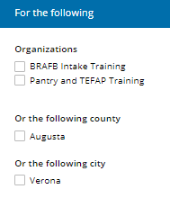
- Click on the program type(s) to be included | 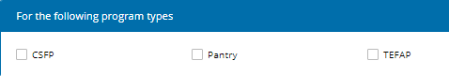
- Click Create Report

Statistics Report
- Click on New Report in the Statistics Report box
- Enter a Title for the report that will make it easy to identify in the Report Inbox | 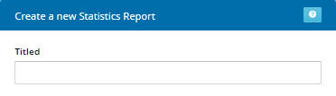
- Click “shared with people...” if you want other Link2Feed users in your pantry to see the report.
You may choose for the report to be launched either on demand or on a schedule.
If you wish to launch the report on demand,skip to Step o.
- To launch the report on a schedule, select the schedule frequency from the list of choices
- Select the date and time when the schedule should begin
- Define the time period, either from the list of values in “Dates Are What I Choose” or by entering a specific Start Date and End Date
HINT: The report can be re-used in subsequent weeks or months if you select a value from “Dates Are What I Choose”
HINT: The Schedule Date and Time Period must be compatible to obtain the desired output | Examples:  Schedule Date = 1st day of month for Time Period = Last Month  Schedule Date = last day of month for Time Period = This Month
- Select the data population by clicking on the appropriate parameter.
The choices are the entire pantry, certain counties or certain cities within the pantry’s service area
- Click on the program type(s) to be included
- Click on the report metrics (sections) to be included | 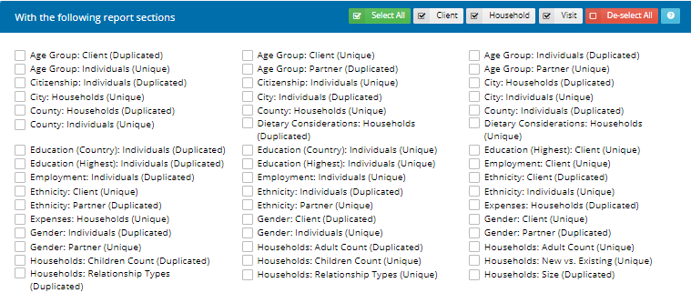
HINT: There are 103 report metrics from which to select, listed in alphabetical order. | The most commonly used choices are:  Age Group: Individuals  Households: Size  Served: Households/Individuals  Visits: Deliveries (pantries that deliver)  Visits: Number of Visits (pantries open >1 day in the period)  Visits: Program Name (reports with multiple programs)
HINT: A report metric may have two forms: unique and duplicated. Unique counts the household or individuals only once for the period if they have multiple visits. Duplicated counts the number of visits and will count households and individuals more than once if they have more than one visit in the period
- Click Create Report

- View Report
- Select Reports from the side menu
- Select Report Inbox | 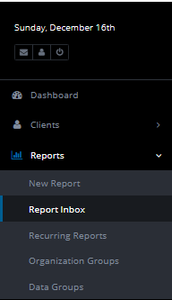
- Identify the desired report in the list of reports | 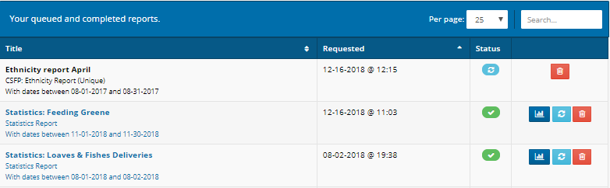
- Determine the Status of the desired report. | 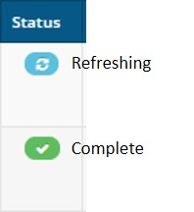
- If the Status is Refreshing, repeat Steps b. and c. until Status is Complete
- Click on the View icon to view the report

- Refresh report
HINT: An on-demand report should be refreshed if new data has been added OR the it is being re-used in subsequent weeks or months
- Select Reports from the side menu
- Select Report Inbox
- Identify the desired report in the list of reports
- Click the Refresh icon
- Repeat Steps b. and c. until Status is Complete
- Click on the View icon to view the report

- Print report
- Select Reports from the side menu
- Select Report Inbox
- Identify the desired report in the list of reports
- Click on the View icon to view the report
- Click Print View button at top right of screen
- Click Print Popup button below report description | 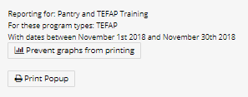
- Verify Destination is correct, then press Print button | 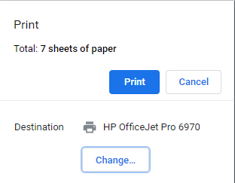

- Export report data
- Select Reports from the side menu
- Select Report Inbox
- Identify the desired report in the list of reports
- Click on the View icon to view the report
- Scroll to the report section you wish to export
HINT: Export data must be performed for each desired report section
- Click Tools icon at right side of report section
- Click on Copy
- Message appears confirming data has been copied to PC clipboard | 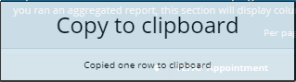
- Open application (example: Excel) to which you wish to save the data and click Paste | 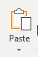
- Data will appear in the application | 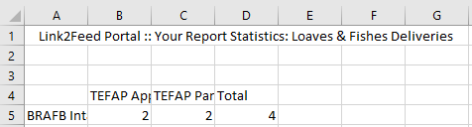
- Repeat Steps l. through p. as required

- Delete report
- Select Reports from the side menu
- Select Report Inbox
- Identify the desired report in the list of reports
RULE: There is no warning message and a deleted report cannot be recovered or restored
- Click on the Delete icon to view the report
- A confirmation will appear, and the report will no longer be in the list of reports | 