PURPOSE
This instruction aid covers the search and selection of a client record

AUDIENCE
Agency employees and volunteers who record client visits to a food pantry

PREREQUISITES
(A) User Log In & PW Reset

INSTRUCTION STEPS
 | New TEFAP | New CSFP | New Pantry
- User Log In
- Search, identify and select client record

Revision History
Dec 1, 2022 Initial Release

- Search, identify and select client record
- If you have just logged in,  click Open in the Case Management box | 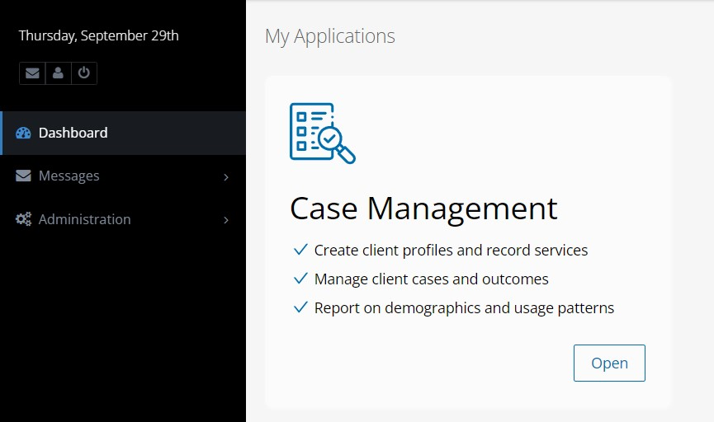
- Select Name as the Search criteria from “Search for Clients By...” | 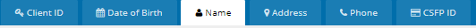
- Enter client Last Name followed by First Name | 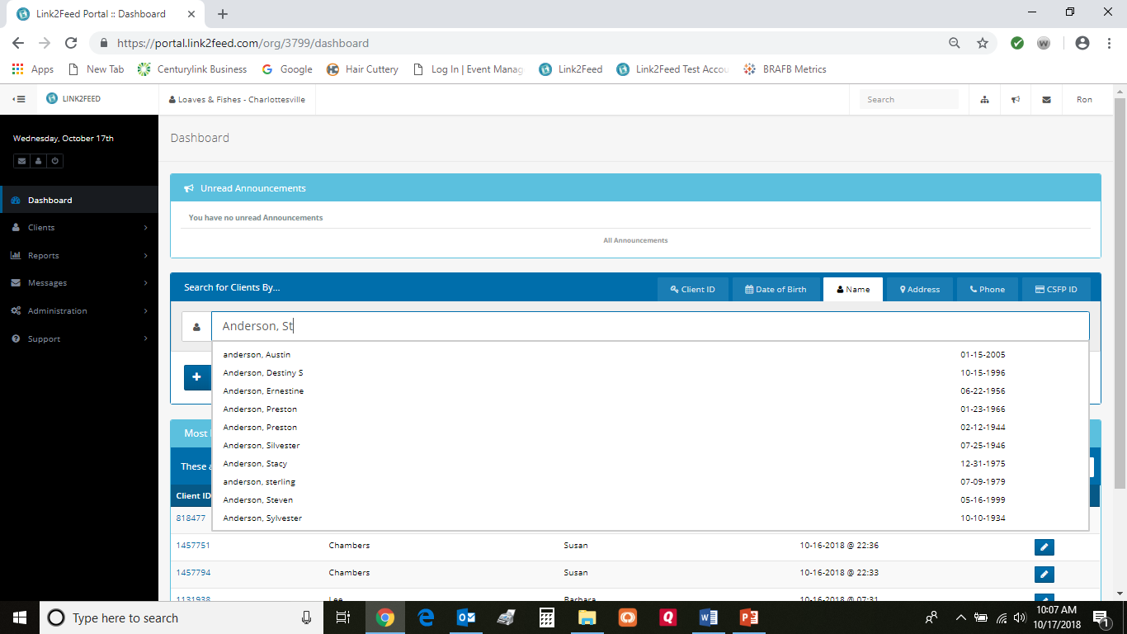
HINT: Watch for client records to be presented in a list as you type the Last Name and First Name. The desired client record MAY appear before you finish typing
- Select the desired client record from the list (highlighted in blue) and click on it | 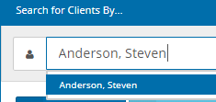
HINT: There may be multiple client records with the same name. Use Date of Birth at the far right to confirm and select the desired client record | 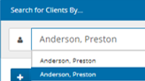  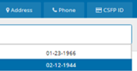
HINT: The client record may have a different first name or last name in the system than the first and last name provided by the client.  Select Date of Birth as the Search criteria from “Search for Clients By...” | 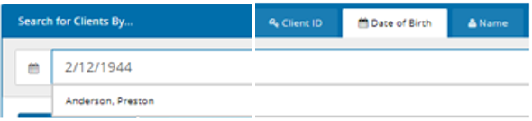
- Select the desired client record from the list (highlighted in blue) and click on it
- Check if there is an Alert (at the top of the screen) and review the associated client note

