PURPOSE
This instruction aid covers the recording of Bulk Program (example: Soup Kitchen) services for an Agency.

AUDIENCE
Agency employees and volunteers who record Bulk Program services to Agency clients

PREREQUISITES
(A) Log In & PW Reset

INSTRUCTION STEPS
- Select Bulk Program service
- Bulk Program: Record service
- Bulk Program: Save the record

- Select Bulk Program
- Select Programs from the side menu | 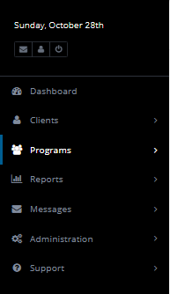
HINT: The side menu will remain visible as you navigate through Link2Feed
- Select Record Data from Programs sub-menu | 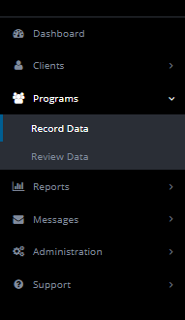
HINT: If “No Programs Found” appears in Available Programs for Bulk Recording screen, contact BRAFB to request it be added to your user role. | 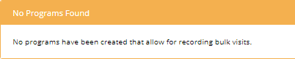

- Click on the desired program | 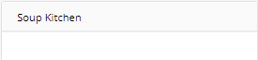
HINT: There are a number of different programs, including “Soup Kitchen”, “Backpack” and “Shelter”

- Record Bulk Program service
- Click “Record Data”
- “Record Data to [Program Name]” will appear at the top of the screen. | 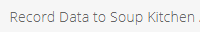
- Enter Number of People Served by age group. Date may be changed if entering data for a previous day | 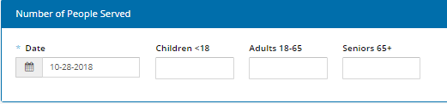
HINT: If you do not separate meals served by age category, record visits under "Adults 18-65" and put "0" in the other sections.

- Save the record
- Click “Save”
- The Bulk Program will appear in the Logs list | 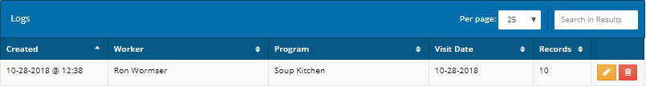
Bulk Program Recording Complete

