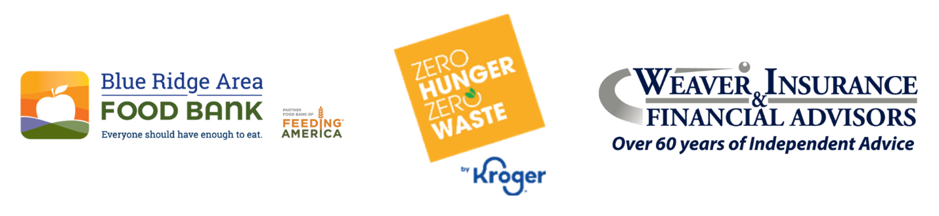
FOR IMMEDIATE RELEASE
March 28, 2024
“Shop to Stop Hunger” Event Provides 47,446 Meals for the Blue Ridge Area Food Bank
Local Leaders Race to Fill Carts in Support of Community Hunger Relief Efforts
[Staunton, Va] — On Thursday, March 27, local community leaders, their cheerleaders, and Kroger representatives came together at the “Shop to Stop Hunger” charity supermarket sweep to benefit the Blue Ridge Area Food Bank. Hosted at Kroger, located in Staunton, contributions from the event raised a total of $15,474 and 1229 pounds of food and funds, totaling 47,446 meals, helping to fill the Food Bank’s shelves and raise awareness of food insecurity across the Blue Ridge region.
During the high-energy 60-second sweep, participants raced down the aisles, filling their carts in a bid to claim the most valuable haul. Jim Simmons emerged as the Grand Champion, winning the coveted “Cart Away Hunger” trophy for the most total donations raised.
The event drew an impressive lineup of participants, including:
- Zanny Bandy (Smoky Row Excavating. Unfortunately, Zanny took ill so Jenna Dull of the Food Bank was her substitute runner)
- Connie Davis (Central United Methodist Church food pantry)
- Priscilla (PJ) Piñeiro Jenkins (Staunton Public Defenders Office)
- Corrie Park (Made: By the People, For the People; Stuart Hall School; City of Staunton Council)
- Jim Simmons (KK Homes Team of Long & Foster)
“Thursday’s event is a powerful reminder of what our community can achieve when we come together,” said Michael McKee, CEO of the Blue Ridge Area Food Bank. “The food and donations raised will provide much-needed meals and hope to families facing food insecurity across our region. We are incredibly grateful to Kroger, Weaver Insurance, and all who participated in making this event a success.”
Impact: Since its inception in 2013, Shop to Stop Hunger has provided more than 821,677 meals to individuals and families across the Blue Ridge region. This year’s event alone will help provide 47,446 meals, with additional donations still being collected.
Support opportunities: Community members can continue to support the Blue Ridge Area Food Bank’s hunger-relief efforts by donating online at https://give.brafb.org/STSHstaunton2025. Every $1 donated helps provide more than three meals.
For more information, please contact:
Les Sinclair
Communications & PR Manager, Blue Ridge Area Food Bank
📞 434-962-5403
📧 lsinclair@brafb.org
Media Materials: https://brafb.sharepoint.com/:f:/s/BRAFBStoryBank/EllJFUbvcvtOpmhEBqYgysMByZGnmxFsrv_olmMNChP0Wg?e=zTfQtG
***
About the Blue Ridge Area Food Bank
The Blue Ridge Area Food Bank is the largest hunger-relief organization serving Western and Central Virginia. Founded in 1981, the Food Bank serves 25 counties and 8 cities through distribution centers in Charlottesville, Lynchburg, Winchester, and its headquarters in Verona. Each month, the Food Bank supports an average of 148,200 guest visits, reaching record numbers of Virginians through a network of nearly 400 community partners—food pantries, soup kitchens, shelters, and program sites. As a partner food bank of Feeding America®, the nation’s largest hunger-relief organization, the Blue Ridge Area Food Bank pledges to continue innovating and adapting to secure, store, and distribute more food to more individuals, families, children, and seniors experiencing hunger. For more information, visit www.brafb.org.

About Kroger’s Mid-Atlantic Division
The Mid-Atlantic Division operates more than 100 stores in Virginia, West Virginia, Kentucky, Tennessee, and Ohio. Based in Richmond, Virginia, the Mid-Atlantic Division employs about 18,000 associates. Kroger is dedicated to eliminating hunger in the communities it serves through partnerships with nine Feeding America food banks and numerous local organizations. The grocer’s Zero Hunger | Zero Waste efforts are aimed at ending hunger in Kroger communities and eliminating waste in stores by 2025. Kroger also supports breast cancer research, the military, and their families and more than 4,000 nonprofit organizations. Last year, Kroger Mid-Atlantic donated 16.5 million meals to charity and 3,606,296 pounds of food to food bank partners.

###

