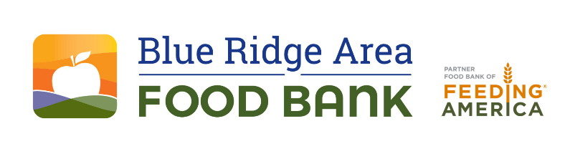
FOR IMMEDIATE RELEASE Contact: Les Sinclair
434-962-5403
lsinclair@brafb.org
www.brafb.org
Blue Ridge Area Food Bank Mobilizes Community for Hunger Action Month
Hunger Action Day is set for September 9.
VERONA, Va. – September 2, 2025 – This September, the Blue Ridge Area Food Bank joins the Feeding America network to mark Hunger Action Month, a nationwide campaign highlighting the urgent need to end hunger and the power of food to nourish more than just the body.
“The need for food assistance is higher than ever, affecting families, seniors, and working people across the Blue Ridge,” said Kari Diener, CEO of the Blue Ridge Area Food Bank. “Our vision is simple: nourishing food and good health for everyone, every day.”
Over the past year, the Blue Ridge Area Food Bank and its network of nearly 400 partner pantries and program sites distributed more than 27 million meals (32 million pounds of food), serving an average of 171,200 people each month. The Food Bank is calling on the community to help sustain this mission:
Take action this September:
- Donate: Every $1 provides 3 meals for neighbors.
- Volunteer: Join the team serving 171,200 people each month.
- Advocate: Speak up for strong hunger-relief policies, including the next Farm Bill.
- Raise Awareness: Share stories, wear orange on Sept. 9, and spark conversations.
“Every action matters — whether it’s giving, volunteering, or raising your voice,” Diener said. “Together, we strengthen our community and prove that no effort is too small to help end hunger.”
According to Feeding America, food insecurity across the U.S. has reached its highest rate in over a decade, with more than 47 million people facing hunger, including 14 million children. Here, in the Blue Ridge region, that translates to 1 in 9 people.
Hunger Action Month is your chance to make a real difference. When you turn compassion into action by donating, volunteering, advocating, or raising awareness, you help move us closer to solving hunger in our community.
Learn how you can change lives at https://www.brafb.org/event/hunger-action-month/
About Blue Ridge Area Food Bank
The Blue Ridge Area Food Bank is the largest hunger-relief organization serving Western and Central Virginia. Founded in 1981, the Food Bank serves 25 counties and 8 cities through distribution centers in Charlottesville, Lynchburg, Winchester, and its headquarters in Verona. Each month, the Food Bank supports an average of 171,200 guest visits, reaching record numbers of Virginians through a network of nearly 400 community partners—food pantries, soup kitchens, shelters, and program sites. As a partner food bank of Feeding America®, the nation’s largest hunger-relief organization, the Blue Ridge Area Food Bank pledges to continue innovating and adapting to secure, store, and distribute more food to more individuals, families, children, and seniors experiencing hunger. For more information, visit www.brafb.org.
###

