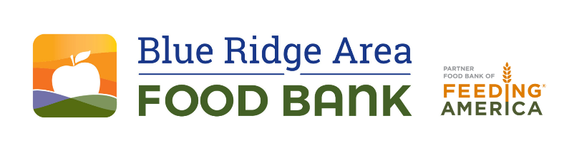
FOR IMMEDIATE RELEASE Contact: Les Sinclair
434-962-5403
lsinclair@brafb.org
www.brafb.org
Blue Ridge Area Food Bank Sponsors Afterschool Meals Program for Children
VERONA, Va. – October 24, 2025 – The Blue Ridge Area Food Bank announces its sponsorship of the At-Risk Afterschool Meals Program for children across the region during the 2025–2026 school year. Through the USDA’s Child and Adult Care Food Program (CACFP), the Food Bank is helping fill critical nutrition gaps by providing free meals at participating sites.
Meals will be provided to all children free of charge. The same meals will be available at no charge to all participants at each site, regardless of race, color, national origin, sex, age, or disability. Participation requirements are the same for all. Individuals not already registered with the program are encouraged to contact the site in advance to ensure proper guidance.
This initiative supplements school-based federal nutrition programs such as free or reduced-price breakfasts, lunches, and snacks, ensuring children have access to healthy meals after school.
Meal Sites and Service Times:
Waynesboro Boys & Girls Club
302 East Main St, Waynesboro, VA
- Snack: Monday–Friday, 3:00–3:30 PM
- Supper: Monday–Thursday, 4:30–5:00 PM
Staunton Boys & Girls Club
1114 West Johnson St, Staunton, VA
- Snack: Monday–Friday, 3:30–3:45 PM
- Supper: Monday–Thursday, 5:30–6:00 PM
College Hill Parks & Rec Center
811 Jackson Street, Lynchburg, VA
- Snack: Monday–Friday, 4:00–4:30 PM
- Supper: Friday, 4:30–5:00 PM
Daniels Hill Parks & Rec Center
317 Norwood Street, Lynchburg, VA
- Snack: Monday - Wednesday & Friday, 4:30–6:00 PM
- Supper: Thursday, 4:30–6:00 PM
Diamond Hill Parks & Rec Center
1005 Seventeenth Street, Lynchburg, VA
- Snack: Monday–Friday, 5:00–5:30 PM
- Supper: Thursday, 5:30–6:00 PM
Fairview Heights Parks & Rec Center
3621 Campbell Ave, Lynchburg, VA
- Snack: Monday–Friday, 3:30–3:45 PM
- Supper: Wednesday, 4:15–4:45 PM
Jefferson Park Center
405 York St, Lynchburg, VA
- Snack: Monday–Friday, 4:00–4:30 PM
- Supper: Thursday, 5:00–5:30 PM
Yoder Center
109 Jackson St, Lynchburg, VA
- Snack: Monday–Friday, 4:00–4:30 PM
- Supper: Thursday, 5:30–6:00 PM
USDA Nondiscrimination Statement
In accordance with Federal civil rights law and U.S. Department of Agriculture (USDA) civil rights regulations and policies, the USDA, its agencies, offices, and employees, and institutions participating in or administering USDA programs are prohibited from discriminating based on race, color, national origin, sex (including gender identity and sexual orientation), disability, age, or reprisal or retaliation for prior civil rights activity in any program or activity conducted or funded by USDA.
Program information may be made available in languages other than English. Persons with disabilities who require alternative means of communication for program information (e.g., Braille, large print, audiotape, American Sign Language, etc.) should contact the agency (State or local) where they applied for benefits. Individuals who are deaf, hard of hearing, or have speech disabilities may contact USDA through the Federal Relay Service at (800) 877-8339.
To file a program complaint of discrimination, complete the USDA Program Discrimination Complaint Form (AD-3027), found online at USDA.gov, or at any USDA office. You may also write a letter with the requested information and submit it by:
- Mail: U.S. Department of Agriculture
Office of the Assistant Secretary for Civil Rights
Washington, D.C. 20250-9410
- Fax: (202) 690-7442
- Email: program.intake@usda.gov
This institution is an equal opportunity provider.
About Blue Ridge Area Food Bank
The Blue Ridge Area Food Bank is the largest hunger-relief organization serving western and central Virginia. Founded in 1981, the Food Bank serves 25 counties and 8 cities through distribution centers in Charlottesville, Lynchburg, Winchester, and its headquarters in Verona. Each month, the Food Bank supports an average of 171,200 guest visits, reaching record numbers of Virginians through a network of 400 community partners—food pantries, soup kitchens, shelters, and program sites. As a partner food bank of Feeding America®, the nation’s largest hunger-relief organization, the Blue Ridge Area Food Bank pledges to continue innovating and adapting to secure, store, and distribute more food to more individuals, families, children, and seniors experiencing hunger. For more information, visit www.brafb.org.

###

